PART I: Short Questions and Answers (25 Points)

- A dialogue/conversation can be represented and visualized with a state machine: TRUE or FALSE?
ANSWER: True. A dialogue/conversation can be represented and visualized with a state machine.

- If so (from QUESTION 1), what concept(s) of Dialogflow CX can be matched with a state of the above state machine?
ANSWER: State is the concept of Dialogflow CX that can be matched with a state of the above state machine. Each page represents a state in a conversation. Based on the input by the user, the next state or page is decided.

- Provide an example of the pair: ENTITY TYPE – LIST OF ENTITY ENTRIES
ANSWER: The data extraction from the user input is controlled based on Entity Types.
Example:
Entity Type: Artist
List of Entity Entries: The Google Dolls, The Goo Fighters, G's N' Roses, Alice Googler.
The below screenshots display the same.

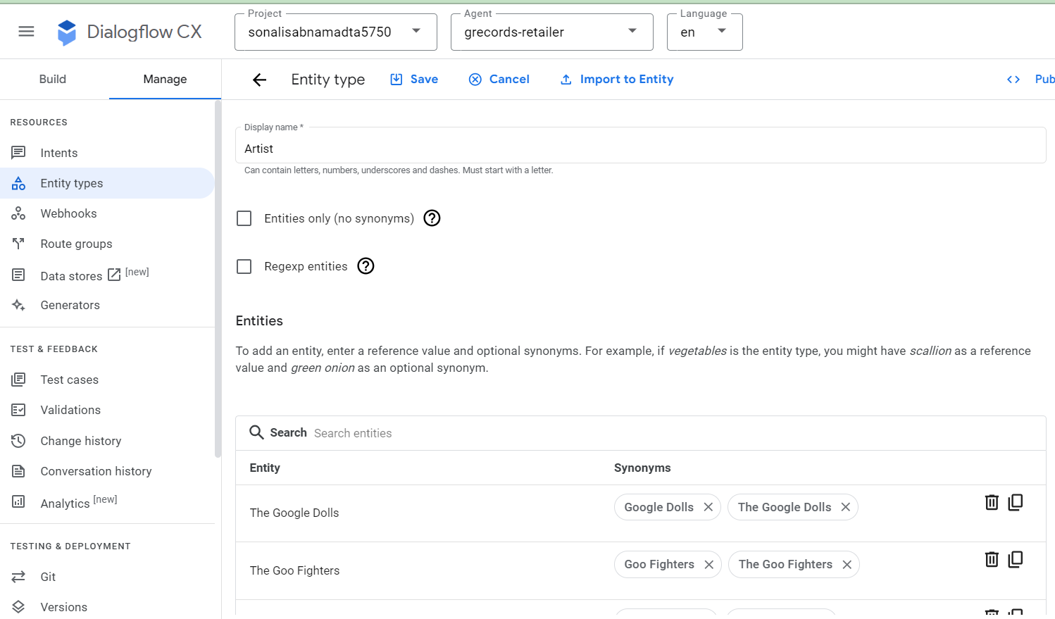

- Provide an example of mapping entities.
ANSWER: The below screenshot shows the entity type “artist” mapped to “Artist Overview” page as a parameter.
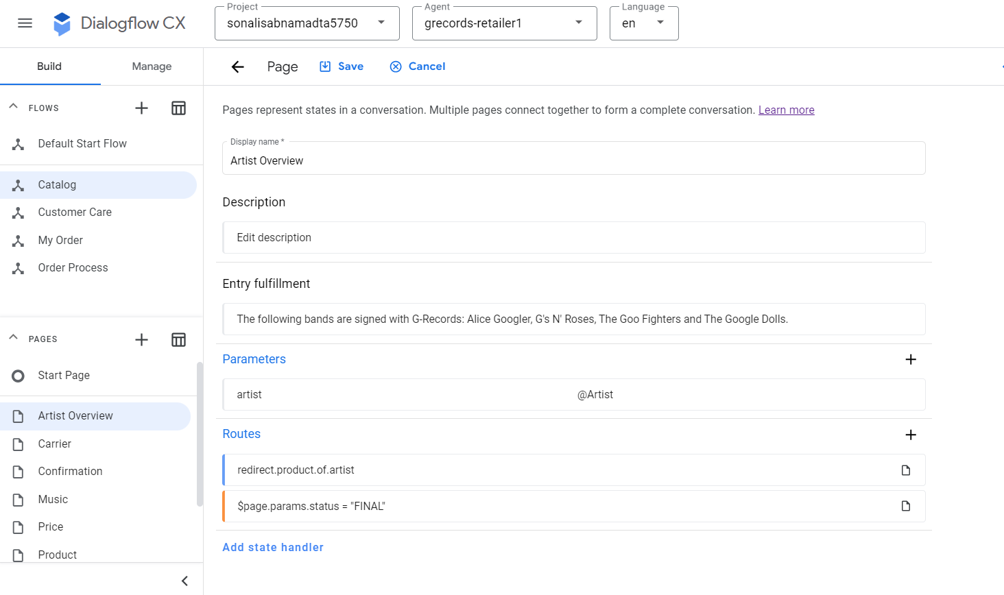
This parameter has a fulfilment, custom payload and “no-match default”, “no-match input”.

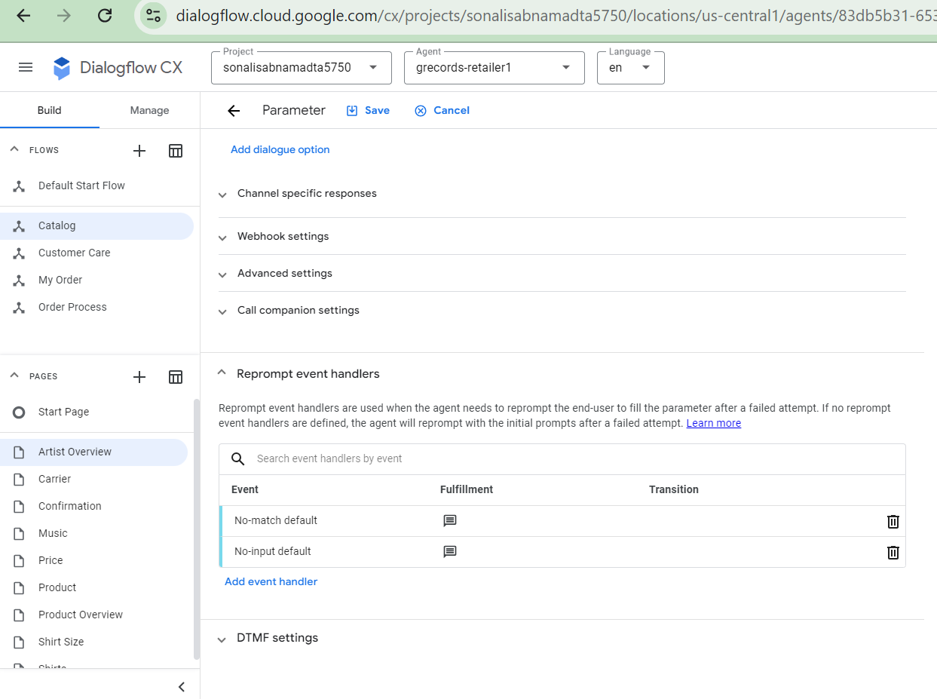

- Describe different types of state handlers
ANSWER: There are two types of state handlers having different handler requirements which are Routes and Event Handlers.
Routes: routes are invoked when the user input matches an intent or some condition on the session status is satisfied.
- Intent Route: a route with an intent requirement is called as intent route.
- Condition Route: a route with an condition requirement is called as condition route.
Event Handlers: called upon event being invoked.
- Built-in events: are triggered upon receiving unexpected user input or webhook error.
- Custom events: can be defined to invoke when something outside of the conversation happens.

- What is a route?
Answer: Route is a type of state handler it is invoked when the user input matches an intent or some condition on the session status is satisfied.
- Intent Route: a route with an intent requirement is called as intent route.
- Condition Route: a route with an condition requirement is called as condition route.

- What is an event handler?
ANSWER: event handler is a type of state handler which is called when an event is invoked.
- Built-in events: are triggered upon receiving unexpected user input or webhook error.
- Custom events: can be defined to invoke when something outside of the conversation happens.

- If a route is applied to a flow and the current page of the flow is the Default Start Page, is the route in scope?
ANSWER: Yes, the route is in scope as the default start page is the current page.

- What routes can be evaluated?
ANSWER: All the routs associated with the current page can be evaluated. These routes may be associated with the intents.

- When handlers are evaluated, which type of handlers is evaluated first?
ANSWER: Event handlers are evaluated first when handlers are evaluated.

- How many pages can be “active” at any moment along a flow of conversation?
ANSWER: Only one page can be active along a flow of a conversation which is the current page.

- What are entity types used for?
ANSWER: are used to control how data from end-user input is extracted. DialogFlow has predefined system entities which can match with many common types of data such as dates, email addresses etc.

- How does Dialogflow find a match in the intent matching process?
ANSWER: An intent classifies the end user's intention for the conversation turn. With the training phrase Dialogflow finds a match in the intent matching process.

- What does Dialogflow try to find in the intent matching: A 100% match or a best match?
ANSWER: When the user provides input (text, speech, or telephone key-presses), Dialogflow compares the input to intent training phrases to get the best match. This process is called intent matching.

- What are training phrases of an intent?
ANSWER: Training phrases are expected input that the user can provide with respect to an intent. For a given intent, we can create many training phrases. When the user input resembles one of these phrases, Dialogflow matches the intent.

- Do we need to define all possible training phrases of an intent?
ANSWER: We don't have to define all possible training phrases, because Dialogflow CX's built-in machine learning expands on the list with other, similar phrases. We shall create a minimum of 10-20 training phases with which the agent can identify the user input.
Example: for favourite color, the training phrases can be:
- “I like red”
- “My favourite color is yellow”
- “green”
- “Blue is my favourite”

- Following the best practices, how many training phrases should be created for each intent, following the best practices?
ANSWER: Following the best practices, there should be a minimum of 10-20 training phrases depending on the complexity of the intent so that the agent can identify the large variety of user inputs.

- What are the types of events? How are events identified?
ANSWER: There are many built-in event handlers such as
- Invalid Parameters
- Utterances too long
- No input,
- No input 1st try
- 2nd try
- No Match.
The difference between no input and no match, is that with no input a user did not provide an answer, whereas with no match, the user did provided an answer, but Dialogflow CX could not intent match this with a page.

- How many steps must be taken to process a state handler? List all of them in the order.
ANSWER: The below three steps are taken to process a state handler.
- Scope: The handler should be in scope to be effective on the session. The scope is determined by whether a handler is applied to a flow, a page, or a form parameter; and if the respective flow is active, the associated page is active, or the agent is currently trying to fill the associated form parameter.
- Evaluation: Each handler in scope is evaluated sequentially. If the handler satisfies the specified condition, it successfully passes the evaluation.
- Call: Once the handler which is present in-scope goes through a successful evaluation, it is invoked. The associated fulfilment is called and associated transition target is applied to the session.

- What scopes can a route be applied to?
ANSWER: The scope is determined when a handler is applied to a flow, a page, or a form parameter; and if the associated flow is active, the associated page is active, or the agent is currently trying to fill the associated form parameter.
Scoping rules for routes are:
- Routes applied to the active flow:
  - If the current page is the flow start page, they are in scope.
  - If the current page is not the flow start page, they are only in scope if they have an intent requirement.
- Routes applied to the current page are in scope.

- What scopes can event handlers be applied to?
ANSWER:
Scoping rules for event handler are:
- Event handlers applied to the active flow are in scope.
- Event handlers applied to the current page are in scope.
Event handlers applied to a form parameter that the agent is currently attempting to fill are in scope.

- If a route is applied to a page, how can it be determined to be in scope or not?
ANSWER:
- They are in scope, if the current page is the flow start page.
- In case the current page is not the flow start page, they are only in scope if they have an intent requirement.

- When are built-in events invoked?
ANSWER: Built-in events are invoked in case of an error or failures. It is similar to exception handling in software applications.

- What is a custom event?
ANSWER: Custom events are created to handle situations that might happen during the
active conversation.
Example: Change in the inventory status during the conversation.

- How many kinds of data can a state handler have? List all of them.
ANSWER: State Handlers have three general types of data.
Handler requirements: These are requirements that should satisfy for the handler to be effective on the session. A handler is called when it’s requirements are met and it impacts the session in any manner.
Handler fulfilment: When a handler is invoked, an optional fulfilment is used to create responses for end-users. These responses can be defined in the static agent data or derived dynamically from the webhook service.
Handler transition target: when a handler is called, the current page is changed by an optional transition target. The next page can be only a flow start page or page within the currently active flow.

- How many types of state handlers are there?
ANSWER: There are two types of state handlers with different handler requirements:
- Routes: When end user input matches the intent or condition on the session status is satisfied, route is called. A route with an intent requirement is called intent route. A route with a condition requirement is called condition route.
- Event handlers: When an event is invoked, an event handler is called.

- When can state handlers be evaluated?
ANSWER: Each handler in scope is evaluated in a sequence. If a handler's requirements are met, it passes evaluation.

- When can state handlers be called?
ANSWER: When a handler is in scope and clears the evaluation, it is invoked. The associated the fulfilment called and the associated transition target is applied to the session.

- Each flow must have at least a page: TRUE or FALSE
ANSWER: True. Each flow must have a at least one page.

- How many phases does the life cycle of a page have? List all of them in the order.
ANSWER: There are six phases of a page life cycle.
- Check for entity fulfilment
- Pre-fill form parameters as needed
- Evaluate any state handlers in scope
- Check for unfilled form parameters
- Send queue, wait for end-user input
- Fill parameter as needed. Continue to step 3.
The below figure displays these six steps.

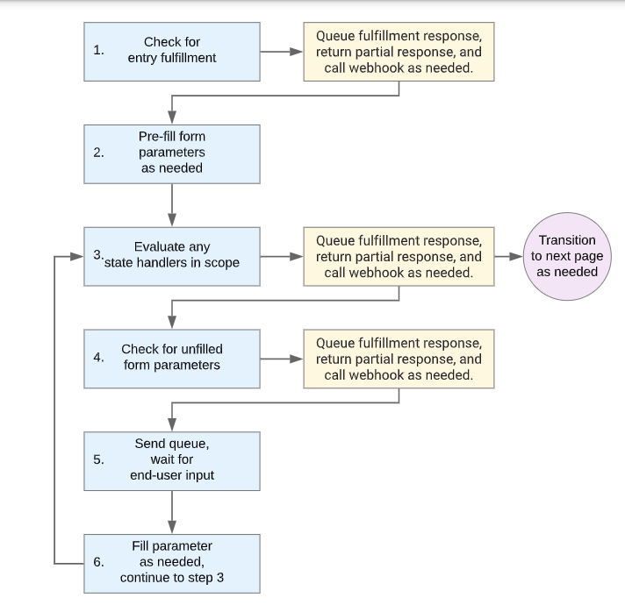
Fig: phase of life cycle of a page

- What happens to the intent, i.e., intent requirement when an intent route is called?
ANSWER: When an intent requirement is satisfied, the intent is consumed, so only the first route handler found for the intent can be called.

- What happens to the condition, i.e., condition requirement when a condition route is called?
ANSWER: When a condition requirement is satisfied, the condition is not consumed, so multiple routes with the condition can be called.

- What happens to the event, i.e., event requirement when an event handler is called?
ANSWER: When an event requirement is satisfied, the event is consumed, so only the first event handler found for the event can be called.

- How is the scope of a state handler (a route or an event handler) determined?
ANSWER: A handler should be in scope to be effective in the session. The scope is established by whether a handler is applied to which kind of entity like page, flow, parameter etc and if the corresponding flow, page, parameter is active or the agent is attempting to fill the corresponding form parameter.

- Provide an example of list entities.
ANSWER: the example for list entities is:
Shopping list entity type:
- Value: Bread, butter, milk, apple, ice cream
- If an end-user input is “I need to buy some carrots”.
- The agent recognizes that “carrot” is contextually like other values.

- Provide an example of composite entities
ANSWER: Composite entity is an entity with multiple entity aliases.
Example: the following move custom entity type that contains aliases of two different entity types.
- Aliases to a direction entity type.
  - Reference value: foreword
  - Reference value: back
- The @sys.number system entity type
  - Value: @sys.number:steps steps @direction:direction
If the move entity is matched with an end-user input that contains “five steps backword”:
- The move entity will be matched.
- The extracted value is returned as: {“steps”:5, “direction”: back}

- Provide an example of regexp entity.
ANSWER: Regex stands for regular expressions. Example for regex entity is:
It is possible to provide the following regular expressions for a phone number:
- ^[2-9]\d{2}-\d{3}-\d{4}$
- ^(1?(-?\d{3})-?)?(\d{3})(-?\d{4})$
The compound regular expression becomes:
- ^[2-9]\d{2}-\d{3}-\d{4}$|^(1?(-?\d{3})-?)?(\d{3})(-?\d{4})$
The ordering of regular expressions matters.
- Each of the regular expressions in the compound regular expression are processed in order.
- Searching stops once a valid match is found.
For example:
- For an end user expression of "Seattle":
  - Sea|Seattle matches "Sea"
  - Seattle|Sea matches "Seattle"

- At least two intents are automatically created when the agent is created. What are they
ANSWER: The below two intents are created by default when the agent is created.
- Default Welcome Intent
- Default Negative Intent

- What major entity options does GCP Dialogflow CX support?
ANSWER: There are two types of entities that can be used in Dialogflow CX: System Entities and Custom Entities
- System entities:
  - Dialogflow provides predefined system entities that can match many common types of data
For example:
--) System entities for matching dates, times, colors, email addresses, to name a few.
- Custom entities:
o It is possible to create custom entities for matching custom data.
For example:
--) It is possible to define a vegetable entity type that includes types of vegetables available in a grocery store.

- Can multiple messages be added to a response queue?
ANSWER: Yes, multiple messages can be added to a response queue.

- Provide an example of a negative training phrase that can be used to train an agent on some intent.
ANSWER: The below phrase is a negative training phrase:
“I want to swap this item for a refund.”
This is used int Part II to test the virtual agent.

- What are two built-in event handlers that are automatically created for any flow?
ANSWER: the below two event handlers are created by default when a new Flow is created.
- Sys.no-match-default
- Sys.no-input-default

- Why do we need pages?
ANSWER: Pages are used to model the states in the virtual agent. The conversation navigates from page to page. At any given point only one page is current. This current page is active and the flow associated with the page is active.

- When is a route called?
ANSWER: Route is called to transition to another page during a conversation. Intent route, condition route and event handlers are three different types of Routes.

- What happens if an intent matching process finds that no intents meet the classification threshold setting?
ANSWER: The default event handler “Sys.no-match-default” is called.

- Can the NO-MATCH event handler of a flow be deleted?
ANSWER: The is no option to delete the no match event handler.

- What is intent propagation? Provide one example to illustrate what happens when intent propagation occurs.
ANSWER: Transferring information from one intent to another is called intent propagation.
Example: If a user asks "Can I buy a t-shirt", the "redirect.shirts" intent gets triggered. However, if the user then asks the size of the t-shirt, the "redirect.shirts" intent propagates the information about the t-shirt to the "redirect.shirt.size" intent, allowing the agent to provide the relevant answer.

- Can multiple pages have a common set of routes?
ANSWER: Yes. multiple pages have a common set of routes.

- How to change the current page to a specific page in another flow?
ANSWER: The current page can be changed to a specific page in another flow by a route.

- A form parameter is also called a re-prompt handler: TRUE or FALSE?
ANSWER: False.

PART II: Develop Conversational AI System for G-Records (45 Points)
SUBMISSION REQUIREMENTS PART II:
--) Submit the report, including the details of each step and the screenshots.
As part of the submission requirement for part II the below report describes the details of each TO-DO task and screenshot for each step.

Introduction
As part of this assignment, we have tried to complete the remaining parts of a DailogFlow CX virtual agent which include:
- Pages & State Handlers
- Conditional Responses
- Wrapping up the agent
- Test your virtual agent

TO-DO #1: Access and read the tutorials on GCP: Dialogflow CX to build a virtual retail agent o At this link
https://codelabs.developers.google.com/codelabs/dialogflow-cx-retail-agent#0

I have read the GCP codelabs document and built a virtual retail agent.
The below screenshot shows the virtual agent “grecords-retauler1” created successfully.

TO-DO #2: Following the steps discussed in the tutorial, complete the steps to set up pages and state handlers.

Objective: In this section, we have built the pages and added the fulfilment, parameters and state handlers. Through state handlers we have created the transition routes to other pages and added conditions to incorporate specific scenarios. We have also added intent routes.

The following steps were taken to build the pages and state handlers.
- Page Intent Routes: Create the pages in the Default start flow
The flow chart below represents the Default Start Flow.
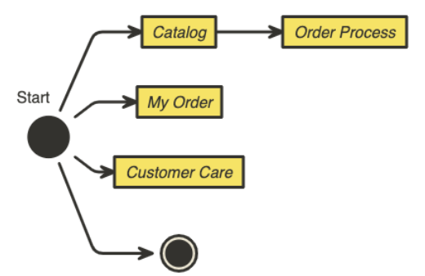
- Click Build > Default Start Flow and select “Start Page”
- Click on the “+” beside the “Route” to add a route.
- Add redirect.artists.overview
- Select transition to “Catalog” flow and save.
- The below screenshot shows the route successfully created.
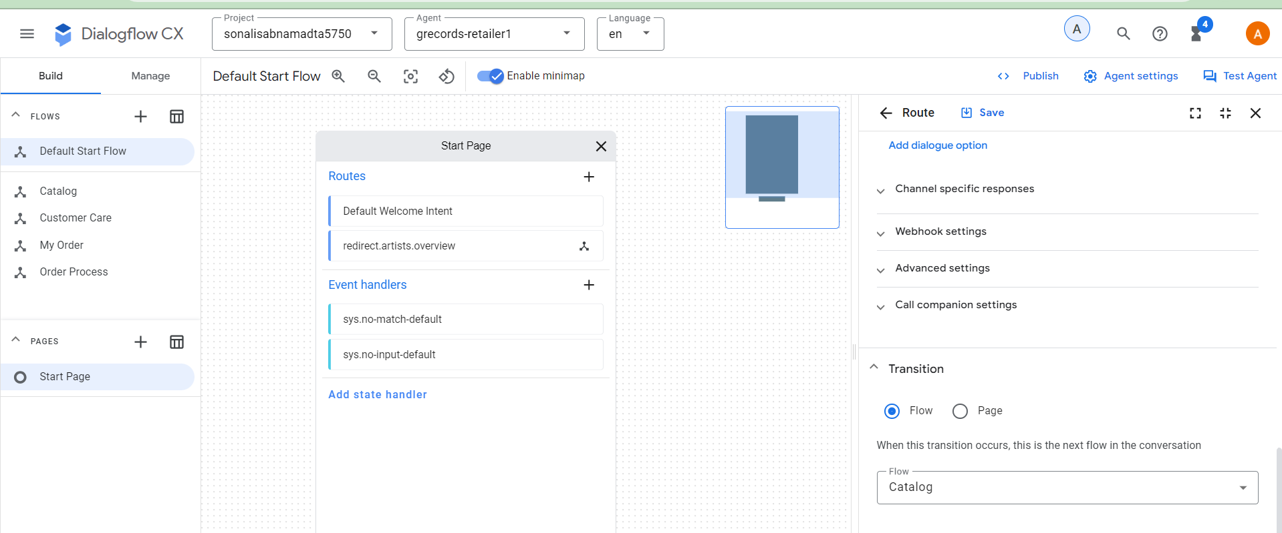

- Repeat the same steps for the routes below.
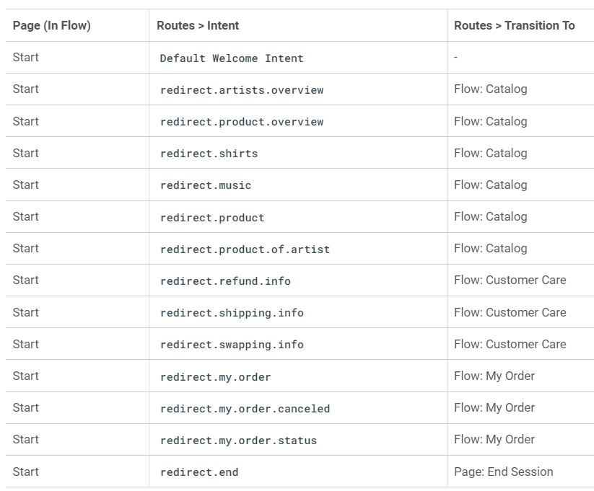
Once the Routes are created the Default Start Flow now looks like the below screenshot.
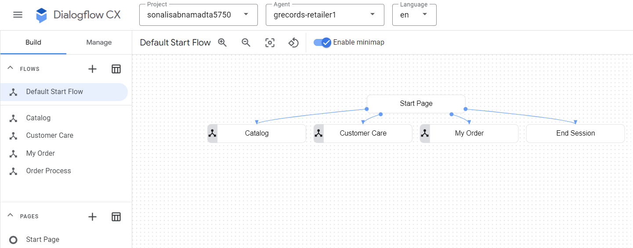

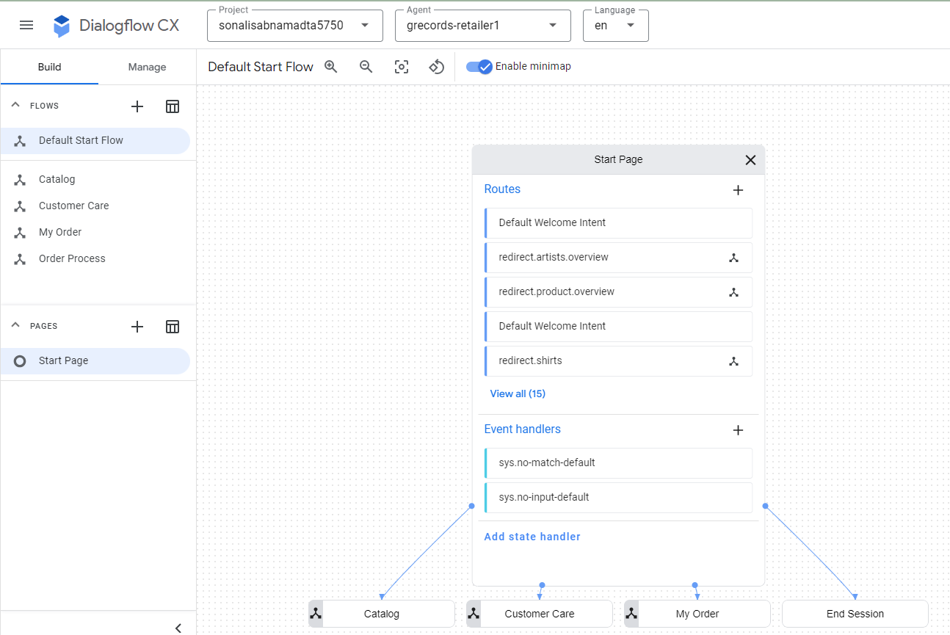

- Connecting the Pages: Follow the below steps to connect the pages.
- Select Built > Catalog > Start Page and click on “+” button beside the Routes.
- Add “redirect.artists.overview”
- In the transition section select page > Add new Page “Artist Overview” and save.
- The route is successfully created.
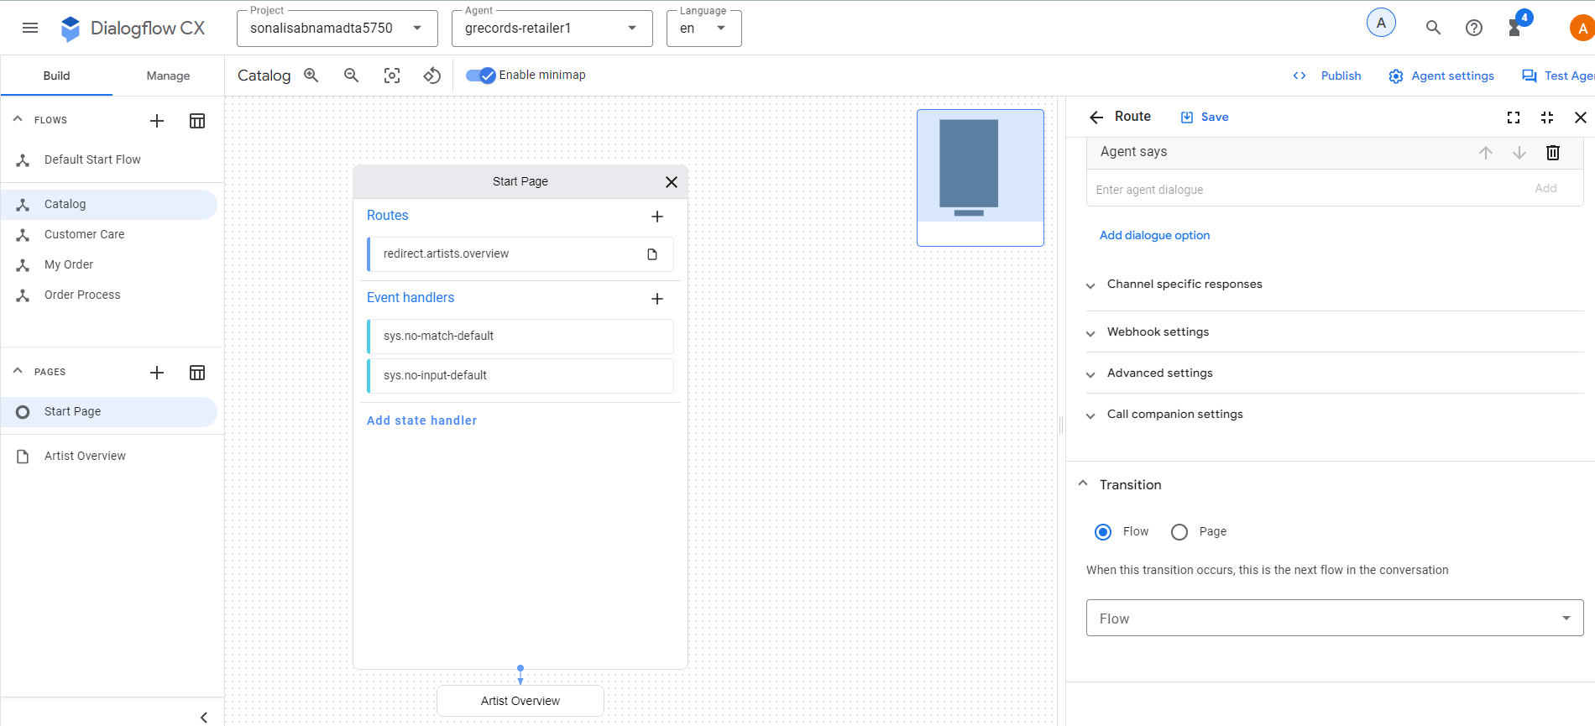
- Repeat the same steps for the below screenshot
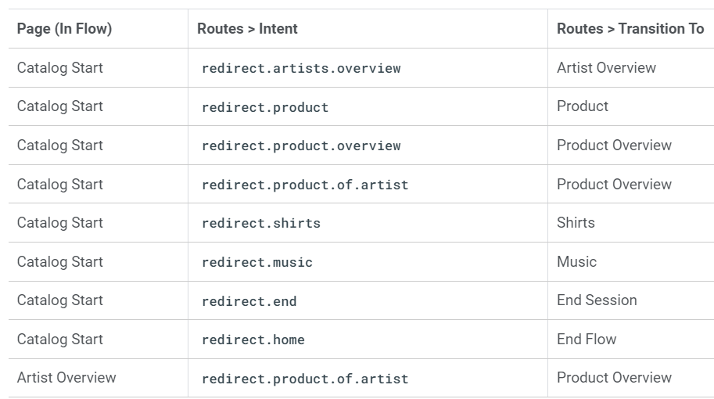
- Once all the routes are created the Catalog Flow looks like the below screenshot.

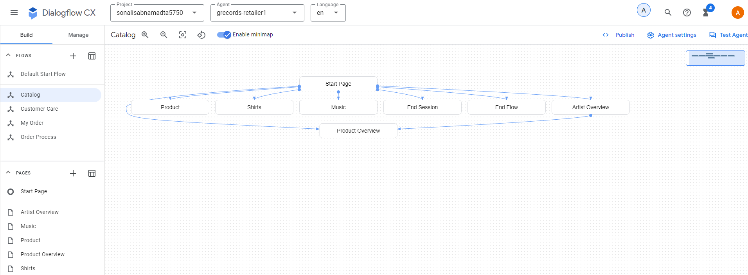
- Follow the steps below to add static fulfilment.
- Catalog Flow > Artist Overview
- Click on “Edit Fulfilment” and provide the below static fulfilment in the “Agent Says” section.
- The following bands are signed with G-Records: Alice Googler, G's N' Roses, The Goo Fighters and The Google Dolls.
- Click on save.
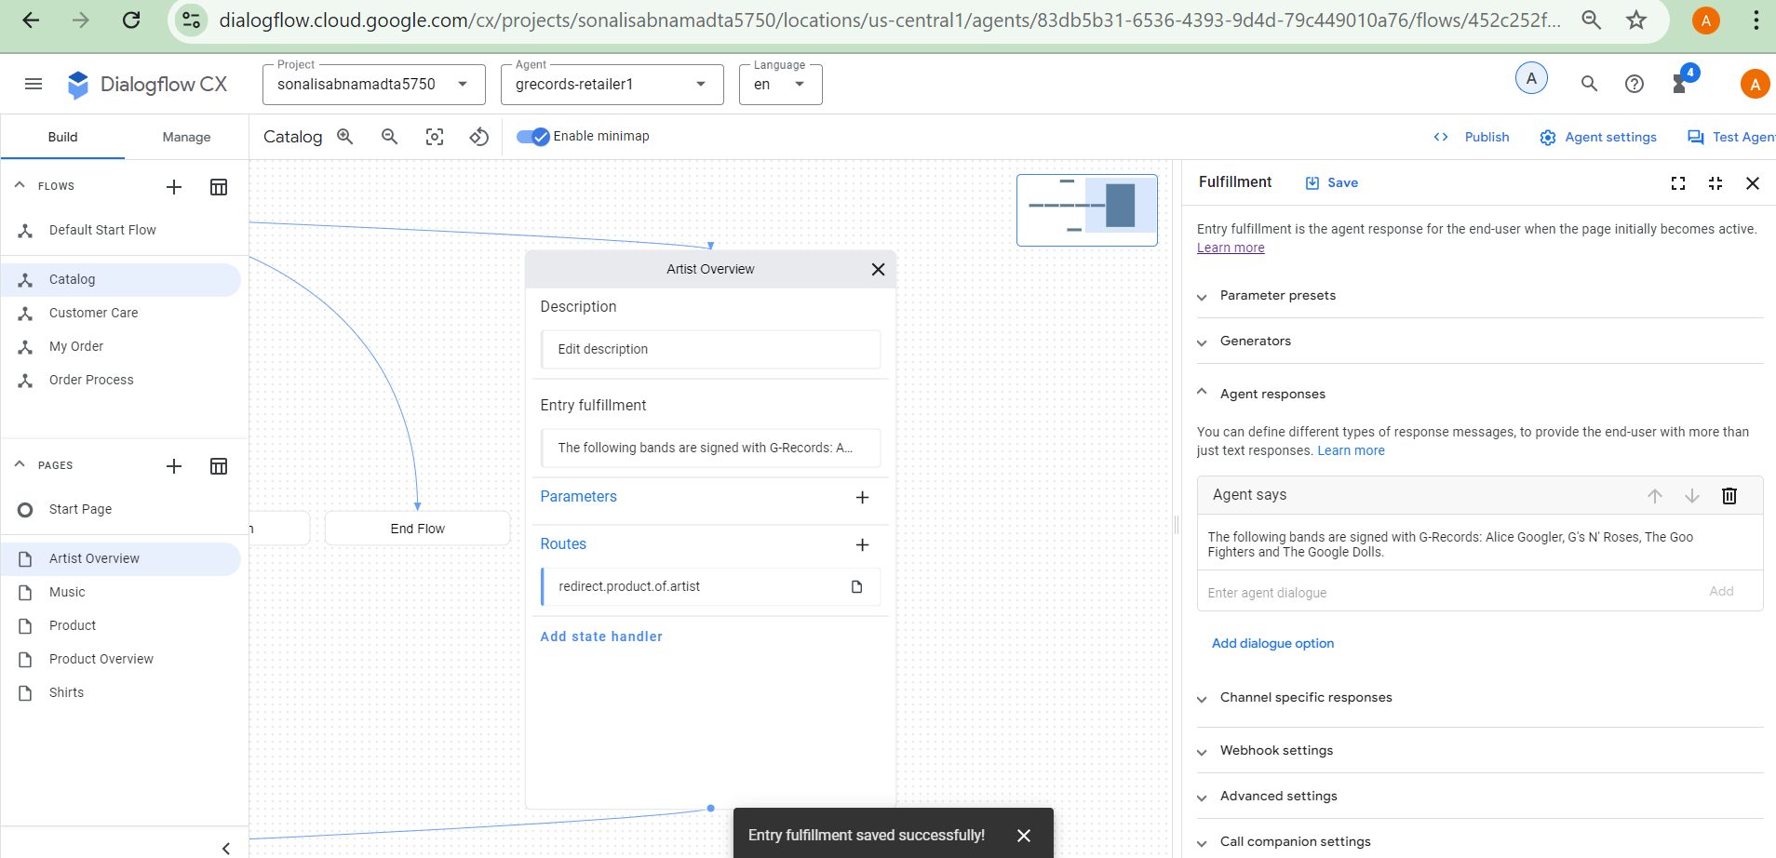
- Repeat the same steps to add “We sell shirts, music or the tour movie.” Static fulfilment to the “Product Overview” page.
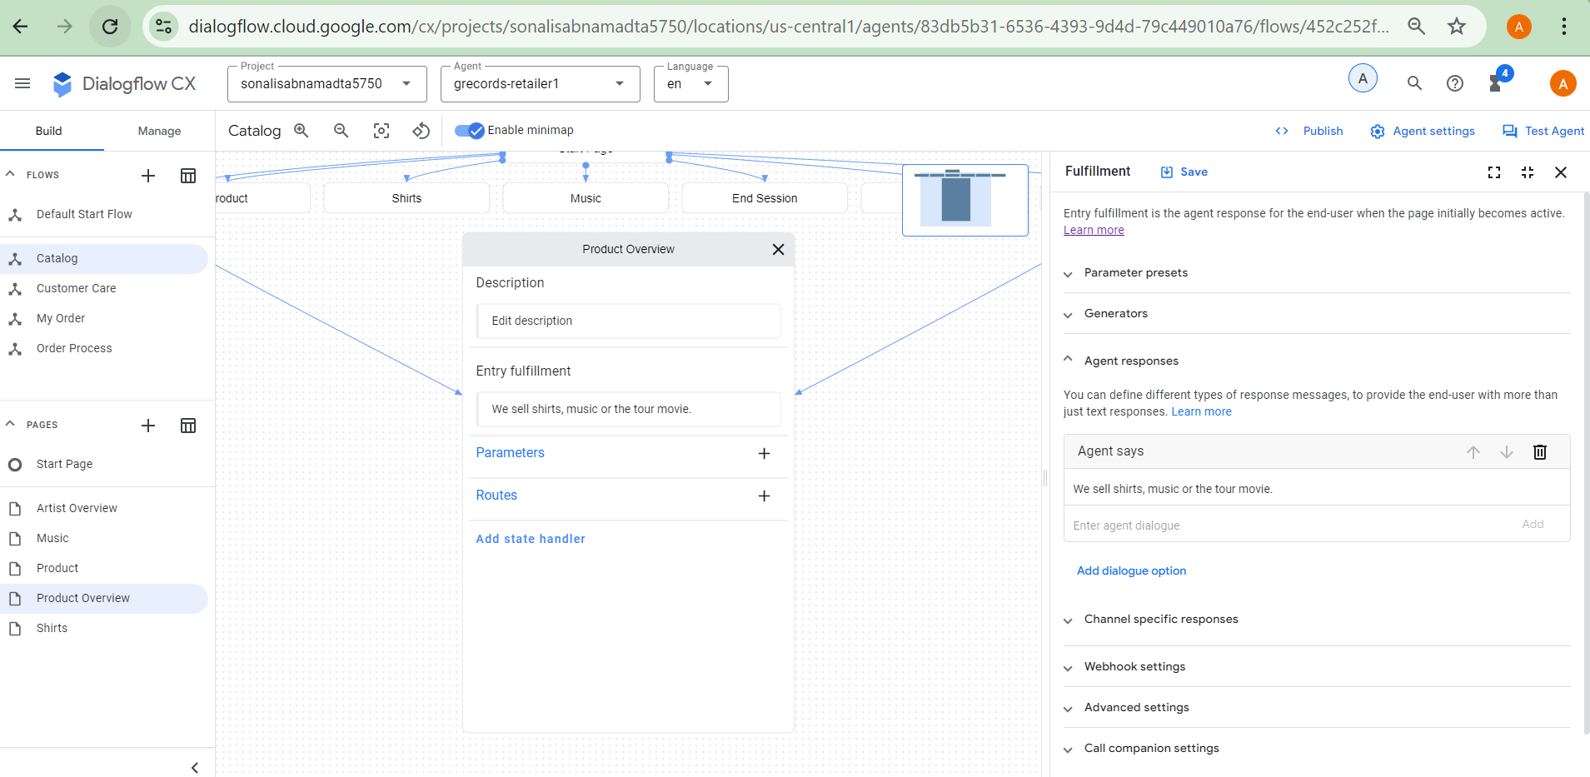
3. Page Parameters: Follow the below steps to Create parameters on the page.
- Select “Catalog Flow” > Artist overview page.
- Click on the “+” beside parameters and add “Artist” parameter.
- Display Name: Artist, Entity Type: @Artist, Required, Redact parameter
- Fulfilment message: “From which of these artists would you like to order merchandise?”
- In the “Add Dialog Option” add the below code in the “Custom payload”
- “{
"richContent": [
[
{
"options": [
{
"text": "The Google Dolls"
},
{
"text": "The Goo Fighters"
},
{
"text": "Alice Googler"
},
{
"text": "G's N' Roses"
}
],
"type": "chips"
}
]
]
}
“

- In the “Reprompt Event Handler” section, add “No-match default” in the event handler section.
- Add the static fulfilment “I missed that. Please, specify the artist. You can choose between: Alice Googler, G's N' Roses, The Google Dolls or The Goo Fighters. Which artist do you want to buy merchandise from?”
- Click on Save.
- Add another event handler “No-input default” with the fulfilment as “I am sorry, I could understand the artist's name. You can choose between Alice Googler, G's N' Roses, The Google Dolls or The Goo Fighters. Which artist do you want to buy merchandise from?”
- Click on Save.
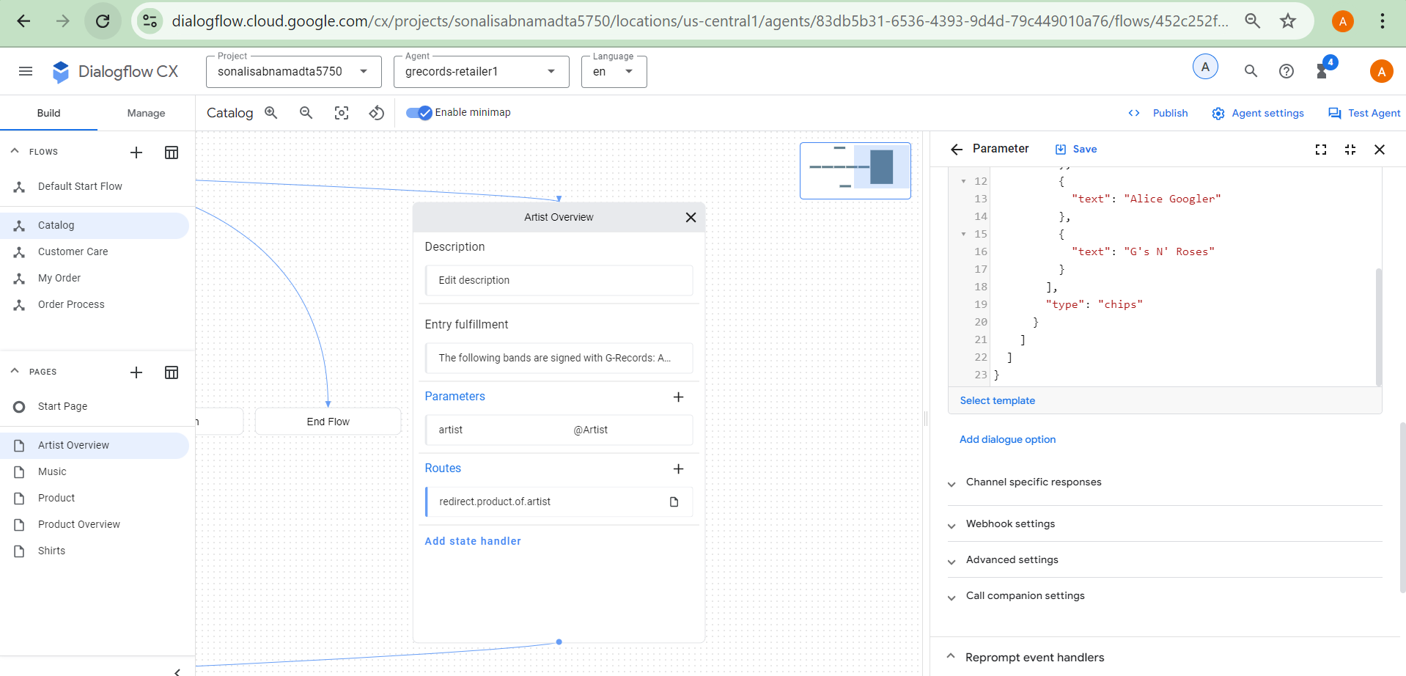

Page Condition Routes
- Conditional routes on the Artist Overview page:
- Select “Artist Overview” page, and click on “+” beside the Routes.
- In the condition section add Parameter: $page.params.status, Operator “=”, Value: “Final”.
- In the fulfilment section, enter the below two lines.
  - $session.params.artist, great choice! Rock on!
  - You want to rock with $session.params.artist merchandise. Awesome!
- Transition to Product Overview page.
- Click on Save.
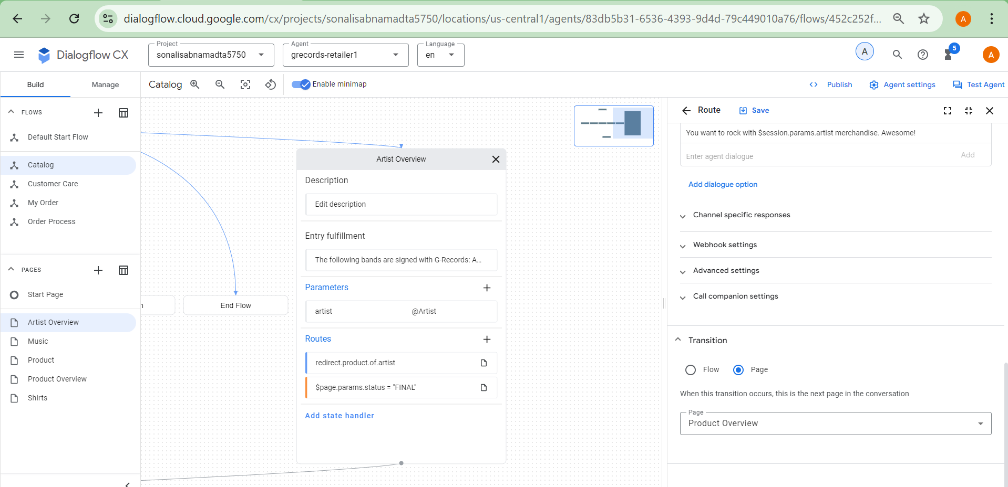
- routes on the Product Overview page
- Create Artist parameter in the Product Overview page with Display name: artist, Entity Type: @Artist, Required , Redact Log.
- Initial Fulfilment: From which of these artists would you like to order merchandise?
- Custom payload:
- {
"richContent": [
[
{
"options": [
{
"text": "The Google Dolls"
},
{
"text": "The Goo Fighters"
},
{
"text": "Alice Googler"
},
{
"text": "G's N' Roses"
}
],
"type": "chips"
}
]
]
}

- Event Handler: No Match Default
- Fulfilment: To buy merchandise you can choose between the following artists: Alice Googler, G's N' Roses, The Google Dolls or The Goo Fighters. Which artist do you want to buy merchandise from?
- Custom Payload:
- {
"richContent": [
[
{
"options": [
{
"text": "The Google Dolls"
},
{
"text": "The Goo Fighters"
},
{
"text": "Alice Googler"
},
{
"text": "G's N' Roses"
}
],
"type": "chips"
}
]
]
}

- Event Handler: No-input default

- Fulfilment: To buy merchandise you can choose between the following artists: Alice Googler, G's N' Roses, The Google Dolls or The Goo Fighters. Which artist were you trying to mention?

- Custom Payload:

{
"richContent": [
[
{
"options": [
{
"text": "The Google Dolls"
},
{
"text": "The Goo Fighters"
},
{
"text": "Alice Googler"
},
{
"text": "G's N' Roses"
}
],
"type": "chips"
}
]
]
}

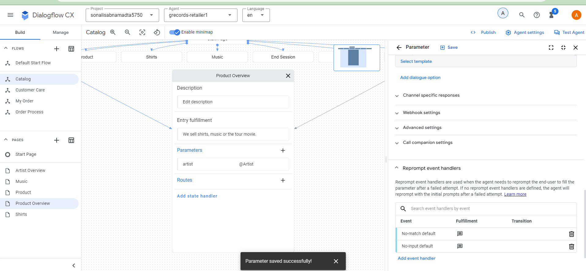
- Create “Merch” parameter.
- Display Name: “Merch”, Entity type: @Merch, Required, Redact log.
- Fulfilment: Which merchandise item do you want?
- Custom Payload:
- {
"richContent": [
[
{
"type": "chips",
"options": [
{
"text": "Shirts"
},
{
"text": "Music"
},
{
"text": "Tour movie"
}
]
}
]
]
}

- Event handler: No-match default

- Fulfilment: We sell Shirts, Music or the Tour movie. Which of these items do you want?

- Custom Payload:

{
"richContent": [
[
{
"type": "chips",
"options": [
{
"text": "Shirts"
},
{
"text": "Music"
},
{
"text": "Tour movie"
}
]
}
]
]
}

- Event handler: no-input Default
- Fulfilment: I couldn't understand which merchandise item you wanted to buy. You can choose between: Shirts, Music or the Tour movie. Which item do you want?
- Custom Payload:
- {
"richContent": [
[
{
"type": "chips",
"options": [
{
"text": "Shirts"
},
{
"text": "Music"
},
{
"text": "Tour movie"
}
]
}
]
]
}
- Add a route for the “Product” page when “artist” and “merch” are provided by following the below steps.
- Click on “+” beside route.
- Condition:
- Match Every rule (AND)
- Expression: $session.params.artist != null
- Expression: $session.params.merch != null
- Fulfilment: Alright! $session.params.merch of $session.params.artist, let's go!
- Transition to “Product” page
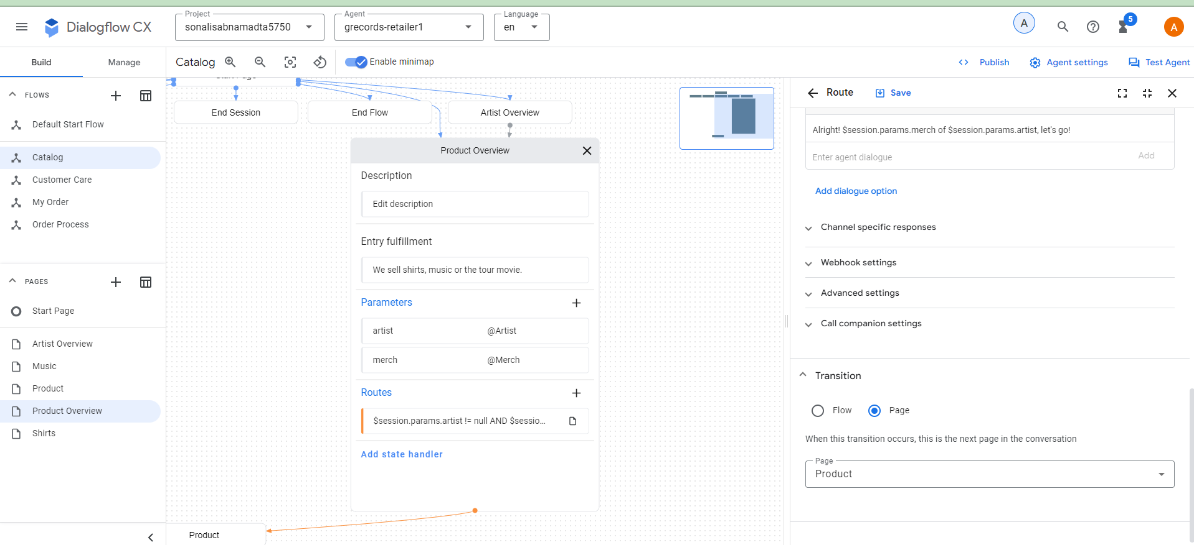
- Create a route for when the user says "Shirts"
- Click “+” beside route and select the intent “redirect.shirts” and transition page to “Shirts”.
- Similarly Create a route for when the user says "Music" and transition to “Music” page for intent “redirect.music”.
- Create route for price information with intent “redirect.price” and transition “Price” page.
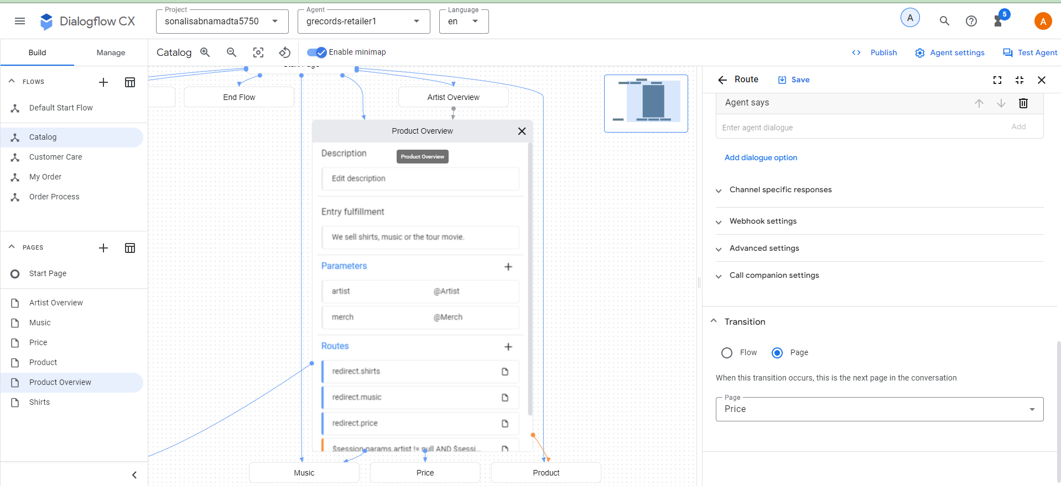
- Till now the agent looks like the below image.
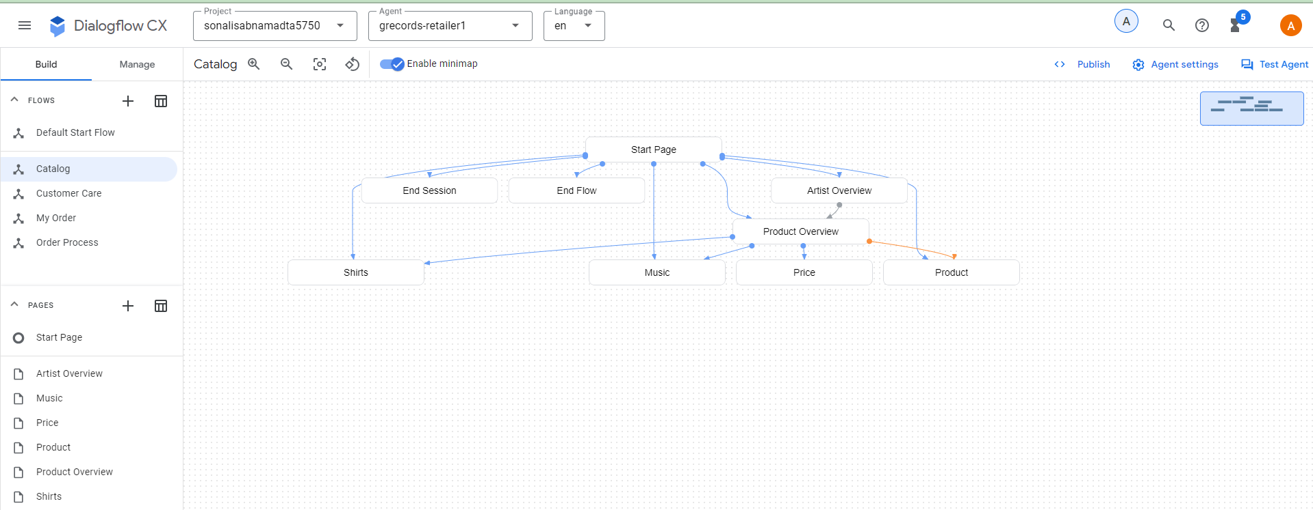
- Use the following configurations to finalize the virtual agent.
- Shirts page, entry fulfilment: Do you want a longsleeve or a t-shirt?
- Custom payload:
- {
"richContent": [
[
{
"type": "chips",
"options": [
{
"text": "T-shirt"
},
{
"text": "Longsleeve"
},
{
"text": "Price?"
}
]
}
]
]
}
- Create an Intent Route: redirect.price with a transition to the Price Page.
- Create the following parameter
- Parameter: merch - Entity Type: @Merch, Required and Redact in log
- Parameter > Event Handler > No-match default
- Parameter > Event Handler Fulfillment: You can choose between a t-shirt or a longsleeve. Which of these do you want?
- Custom payload
- {
"richContent": [
[
{
"type": "chips",
"options": [
{
"text": "T-shirt"
},
{
"text": "Longsleeve"
}
]
}
]
]
}
- Parameter > Event Handler > No-input default
- Parameter > Event Handler Fulfillment: I couldn't understand if you want the t-shirt or the longsleeve. Which of these do you want?
- Custom payload:
- {
"richContent": [
[
{
"type": "chips",
"options": [
{
"text": "T-shirt"
},
{
"text": "Longsleeve"
}
]
}
]
]
}
- In the parameter presets add “category” as parameter and value as “shirts”.
- Add a conditional route: Match At Least One Rule (OR), $session.params.merch = "T-shirt" , $session.params.merch = "Longsleeve", Shirt Size as a new transition page.
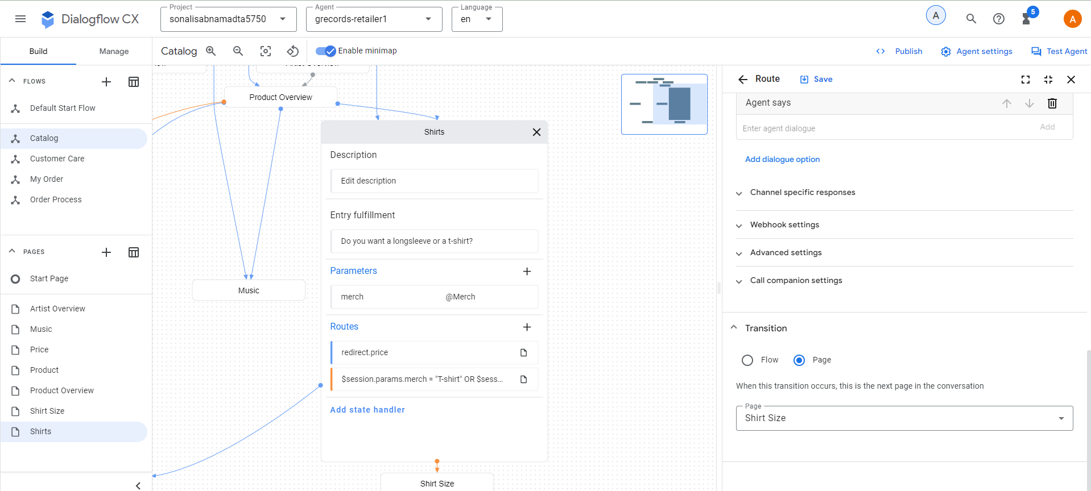
- Till now the agent looks like the screenshot below.
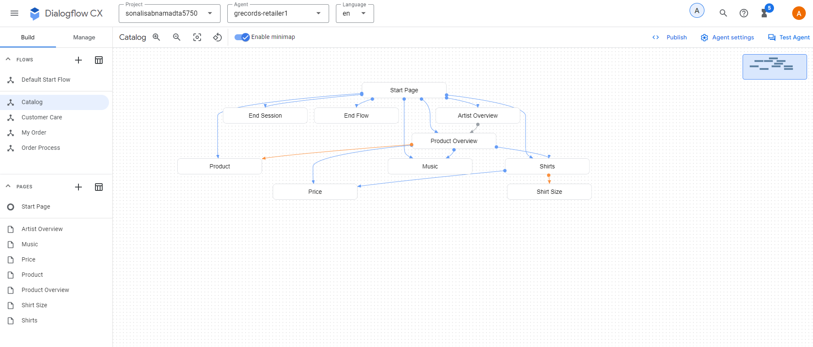
- Create the following configurations for the Price page.
- Entry fulfilment: PRICE TODO
- Add the below condition routes
- Match Every rule (AND),Expression: $session.params.category = "shirts" Expression: $session.params.merch = "null", Transition to new page: Shirts
- Match Every rule (AND),Expression: $session.params.category = "shirts",Expression: $session.params.size = "null",Transition to new page: Shirt Size
- Match Every rule (AND),Expression: $session.params.category = "music",Expression: $session.params.album = "null",Transition to new page: Music
- Match Every rule (AND),Expression: $session.params.category = "music",Expression: $session.params.merch = "null",Transition to new page: Carrier
- Match Every rule (AND),Expression: $session.params.category = "null",Transition to new page: Product Overview
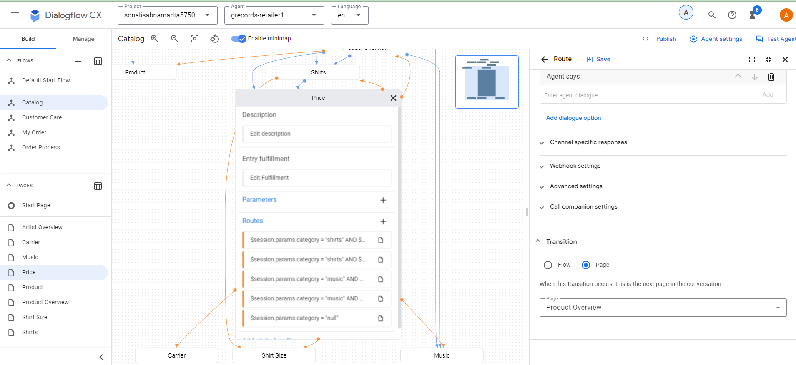
- So far the agent looks like the below screenshot.
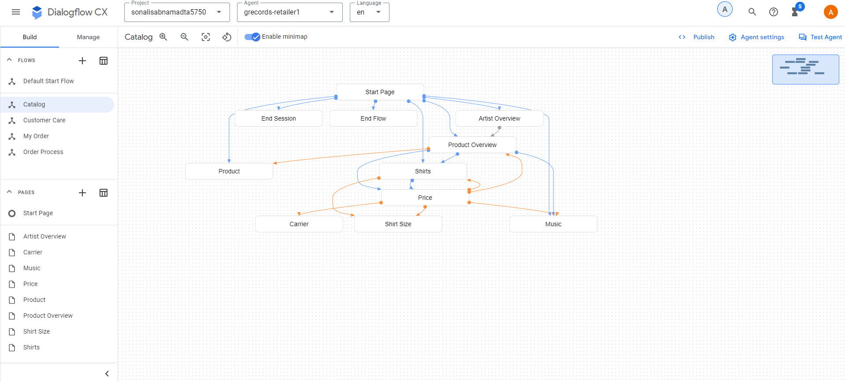
- Create the following configurations in the Shirt Size Page
- Entry fulfillment: What shirt size do you want?
- Custom payload:
- {
"richContent": [
[
{
"type": "chips",
"options": [
{
"text": "XS"
},
{
"text": "S"
},
{
"text": "M"
},
{
"text": "L"
},
{
"text": "XL"
},
{
"text": "2XL"
},
{
"text": "3XL"
}
]
}
]
]
}

- Create an Intent route with “redirect.price” with a transition to the “Price” Page.

- Parameter: shirtsize - Entity Type: @ShirtSize - Required, Redact In Log, Event Handler > No-match default, Parameter > Event Handler Fulfillment: Please tell me the shirt size, such as XL.

- Custom payload:

{
"richContent": [
[
{
"type": "chips",
"options": [
{
"text": "XS"
},
{
"text": "S"
},
{
"text": "M"
},
{
"text": "L"
},
{
"text": "XL"
},
{
"text": "2XL"
},
{
"text": "3XL"
}
]
}
]
]
}

- Parameter > Event Handler > No-input default,Parameter > Event Handler Fulfillment: I couldn't understand the shirt size. What size do you want?
- Custom payload:
- {
"richContent": [
[
{
"type": "chips",
"options": [
{
"text": "XS"
},
{
"text": "S"
},
{
"text": "M"
},
{
"text": "L"
},
{
"text": "XL"
},
{
"text": "2XL"
},
{
"text": "3XL"
}
]
}
]
]
}
- Add a Conditional Route, Match Every rule (AND), Expression: $page.params.shirtsize != "null",Transition to Page "Product"
- Create the following configurations in the Music Page
- Click on Entry fulfillment and add “We have a Greatest Hits Album or the Live Album. Which one do you want?”
- Custom payload:
- {
"richContent": [
[
{
"type": "chips",
"options": [
{
"text": "Greatest Hits"
},
{
"text": "Live"
},
{
"text": "Price?"
}
]
}
]
]
}
- Create an Intent Route: redirect.price, transition Page: Price
- Create the parameter:
- Parameter: album - Entity Type: @Album - Required, Redact In Log
- Parameter > Event Handler > No-match default
- Parameter > Event Handler Fulfillment: You can choose between Greatest Hits and Live Album. Which of these do you want?
- Custom payload:
- {
"richContent": [
[
{
"type": "chips",
"options": [
{
"text": "Greatest Hits"
},
{
"text": "Live"
}
]
}
]
]
}
- Parameter > Event Handler > No-input default
- Parameter > Event Handler Fulfillment: I couldn't understand if you want the album: Greatest Hit or Live. Which of these do you want?
- Custom payload:
- {
"richContent": [
[
{
"type": "chips",
"options": [
{
"text": "Greatest Hits"
},
{
"text": "Live"
}
]
}
]
]
}
- Add the following parameter:
- Parameter: Category, Value: “music”
- Add a Conditional Route: Match Every rule (AND), Expression: $page.params.album != "null", Transition to Page: Carrier
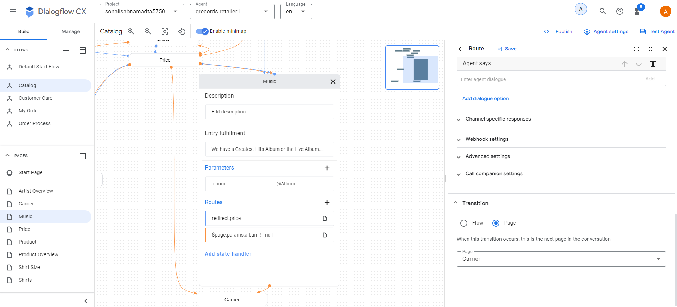
- Till now, the agent looks like this.
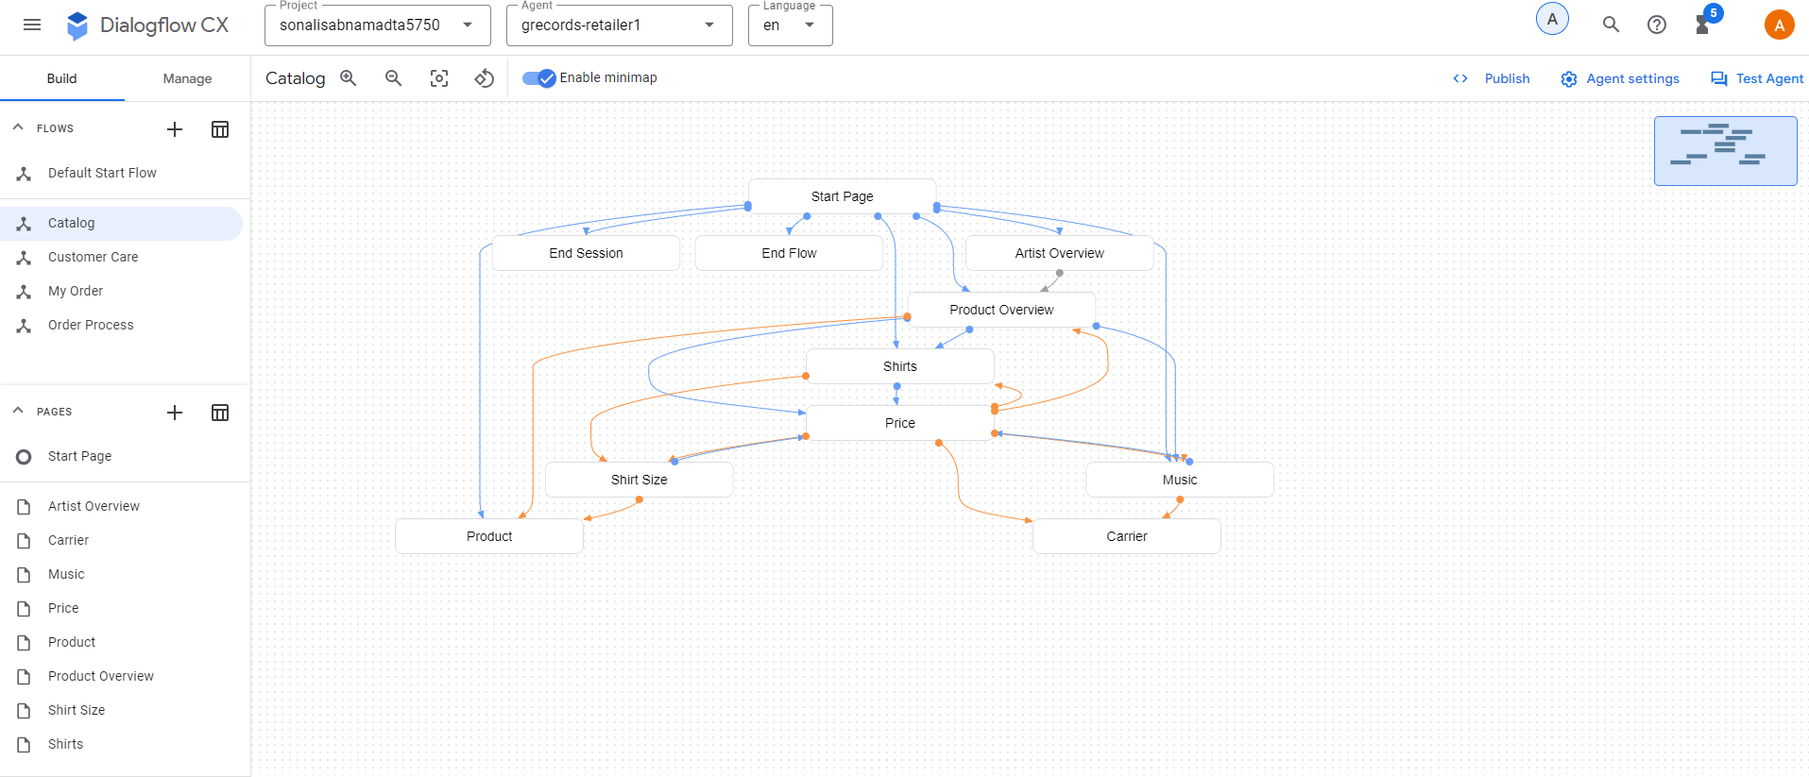
- Create the following configurations in the Carrier Page
- Create the merch parameter:
- Parameter: merch - Entity Type: @Merch - Required, Redact In Log
- Parameter > Event Handler > No-match default
- Parameter > Event Handler Fulfillment: Do you want a physical CD or the digital album?
- Custom payload:
- {
"richContent": [
[
{
"type": "chips",
"options": [
{
"text": "CD"
},
{
"text": "Digital Album"
}
]
}
]
]
}
- Add the below parameter:
- Parameter > Event Handler > No-input default
- Parameter > Event Handler Fulfillment: I couldn't understand if you mean CD or MP3. Which one do you want?
- Custom payload:
- {
"richContent": [
[
{
"type": "chips",
"options": [
{
"text": "CD"
},
{
"text": "MP3"
}
]
}
]
]
}
- Add the Conditional Route: Match Every rule (AND),Expression: $page.params.merch != "null",Transition to Page: Product
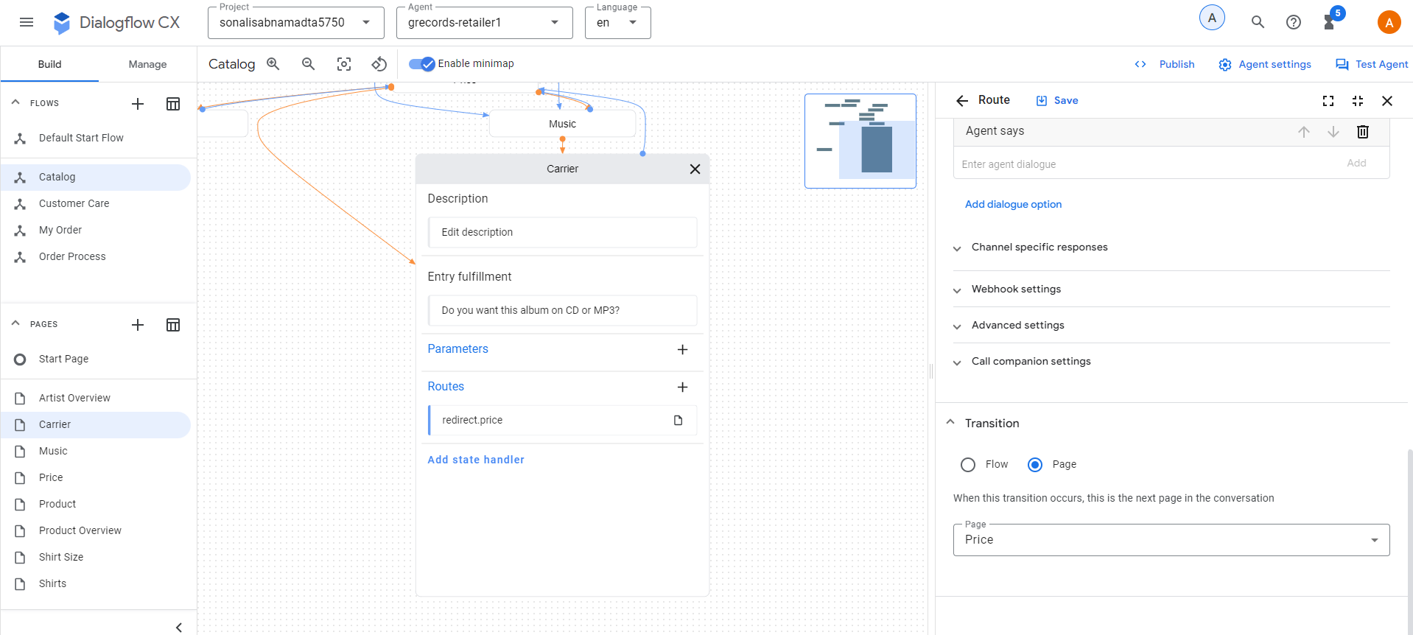
- Till now the agent looks like this.
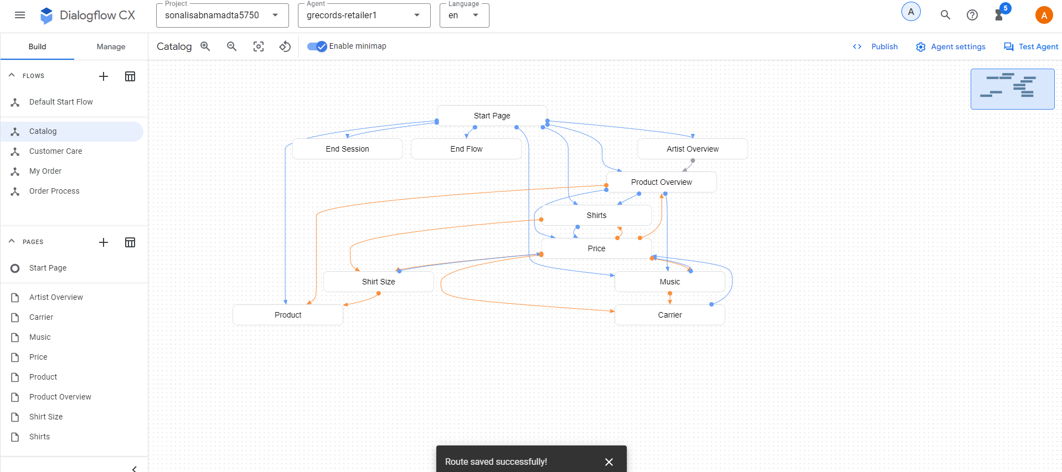
- Create the below parameters for the “Product Page”.
- Parameter Displayname: artist, Parameter Entity Type: @Artist, Required, Redact in log
- Parameter Displayname: merch, Parameter Entity Type: @Merch, Required, Redact in log
- Add the below configuration for “artist”
- Fulfilment: You didn't mention which artist you are interested in. You can ask me to buy the $session.params.merch of the artist you like or ask which artists we signed. How can I help?
- Custom Payload:
- {
"richContent": [
[
{
"options": [
{
"text": "Which artists?"
}
],
"type": "chips"
}
]
]
}
- event handler: No-input default, fulfillment: I couldn't understand what you just said. Ask me which artists are signed.
- event handler: No-match default, fulfillment: I missed that. Please ask me which artists are signed.
- Add the below for “merch”
- event handler: No-input default, fulfillment: I couldn't understand what you just said. Which merchandise item do you want?
- event handler: No-match default, fulfillment: I missed that. Which merchandise item do you want?
- The below Routes are for “Tour Movie”
- Conditional Route: Match Every rule (AND), Expression: $session.params.artist != null, Expression: $session.params.merch = "Tour Movie", Parameter Presets Add Parameter > price = 25, Transition new page: Confirmation
- Create a conditional route with the below detail:
- Custom Expression: $session.params.artist != null AND $session.params.merch = "T-shirt" AND $session.params.shirtsize != null,Parameter Presets Add Parameter > price = 25, Transition page: Confirmation
- Custom Expression: $session.params.artist != null AND $session.params.merch = "Longsleeve" AND $session.params.shirtsize != null, Parameter Presets Add Parameter > price = 30, Transition to page: Confirmation
- Custom Expression: $session.params.artist != null AND $session.params.merch = "CD" AND $session.params.album != null, Parameter Presets Add Parameter > price = 15, Transition to page: Confirmation
- Custom Expression: $session.params.artist != null AND $session.params.merch = "Digital Album" AND $session.params.album != null, Parameter Presets Add Parameter > price = 10, Transition to page: Confirmation
- Custom Expression: $session.params.artist != null AND ($session.params.merch = "CD" OR $session.params.merch = "Digital Album") AND $session.params.album = null, Fulfillment: I would also need to know which album you would like to buy!, Transition to page: Music
- Custom Expression: $session.params.artist != null AND ($session.params.merch = "T-shirt" OR $session.params.merch = "Longsleeve") AND $session.params.shirtsize = null, Fulfillment: I would also need to know which shirt size you need!, Transition to page: Shirt Size
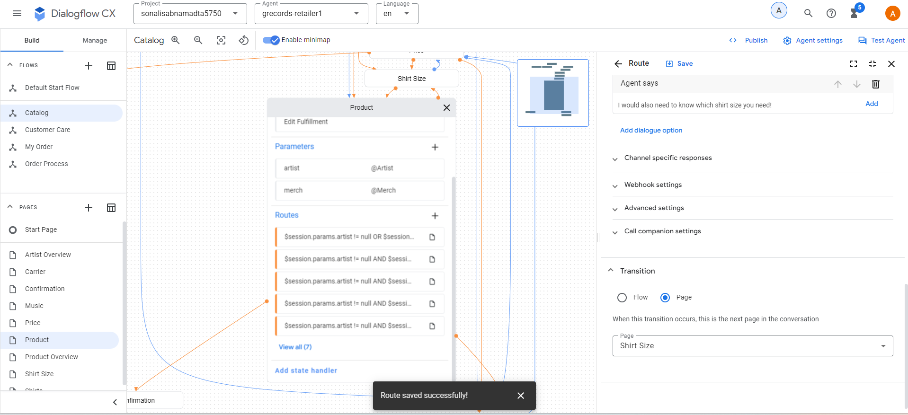
- The agent till now looks like:
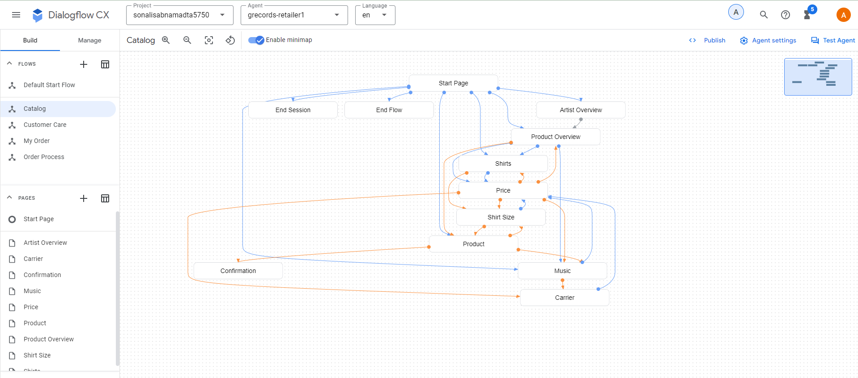

TO-DO #3: Next, complete the steps to add conditional responses.

Objective: In this section, we have created conditional responses for the virtual agent “grecords-retailer1”. Conditional responses generate a specific response based on the input.

The below mentioned steps were taken to complete the conditional responses.
- Confirmation Page:
- Click on the “Confirmation” page and go to “edit fulfilment” > agent responses > Add dialog option > Conditional Response and add the below code.
- if ($session.params.merch = "CD" OR $session.params.merch = "Digital Album")
The $session.params.merch: $session.params.artist - $session.params.album costs $$session.params.price. Shall I continue to order?
elif ($session.params.merch = "T-shirt" OR $session.params.merch = "Longsleeve")
A $session.params.merch of $session.params.artist size: $session.params.shirtsize costs $$session.params.price. Shall I continue to order?
elif $session.params.merch = "Tour Movie"
The $session.params.merch of $session.params.artist costs $$session.params.price. Shall I continue to order?
else
It looks like something went wrong with your order. You can say "Reset", to restart the order process.
endif
- Custom payload:
- {
"richContent": [
[
{
"options": [
{
"text": "Yes, confirm"
}
],
"type": "chips"
}
]
]
}

- Create intent route: confirm.proceed.order, transition: Order Process Flow.

- Create intent route: decline.proceed.order, transitions: End Flow
- Create intent route: decline.proceed.order, add the below parameters and values
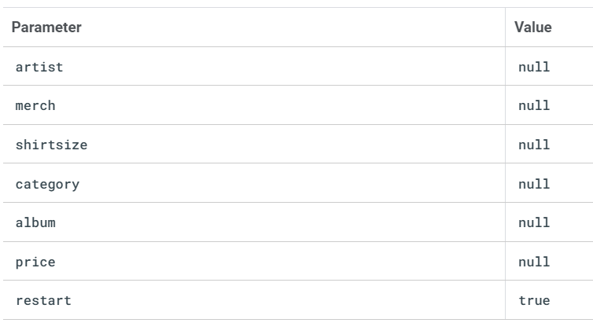
- Click on Default Start Flow, Start page and create the below conditional route.
- $session.params.restart = "true"
- Fulfilment: "Welcome back, as the virtual agent of G-Records, I can help you order artists merchandise, you can ask questions about your order or shipping, and I can tell you more which artists are currently signed with us. How can I help?"
- Custom payload:
- {
"richContent": [
[
{
"type": "chips",
"options": [
{
"text": "Which artists?"
},
{
"text": "Which products?"
},
{
"text": "About my order..."
}
]
}
]
]
}

- Select the Start page and click on “redirect.end” intent, fulfilment: Thank you for contacting G-Records! Have a nice day!
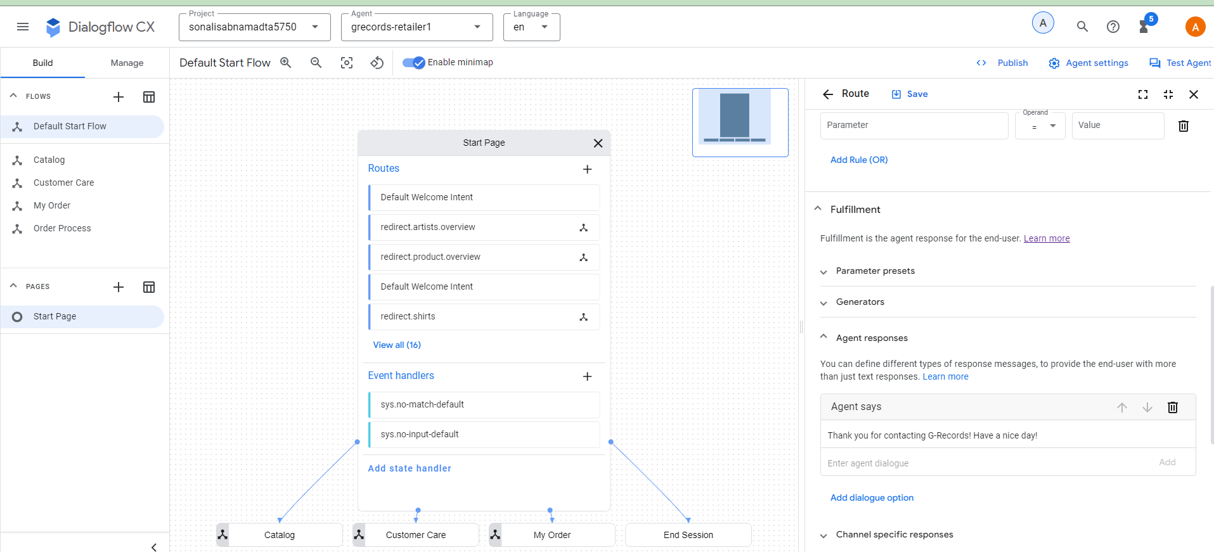
- Till now the agent looks like this:
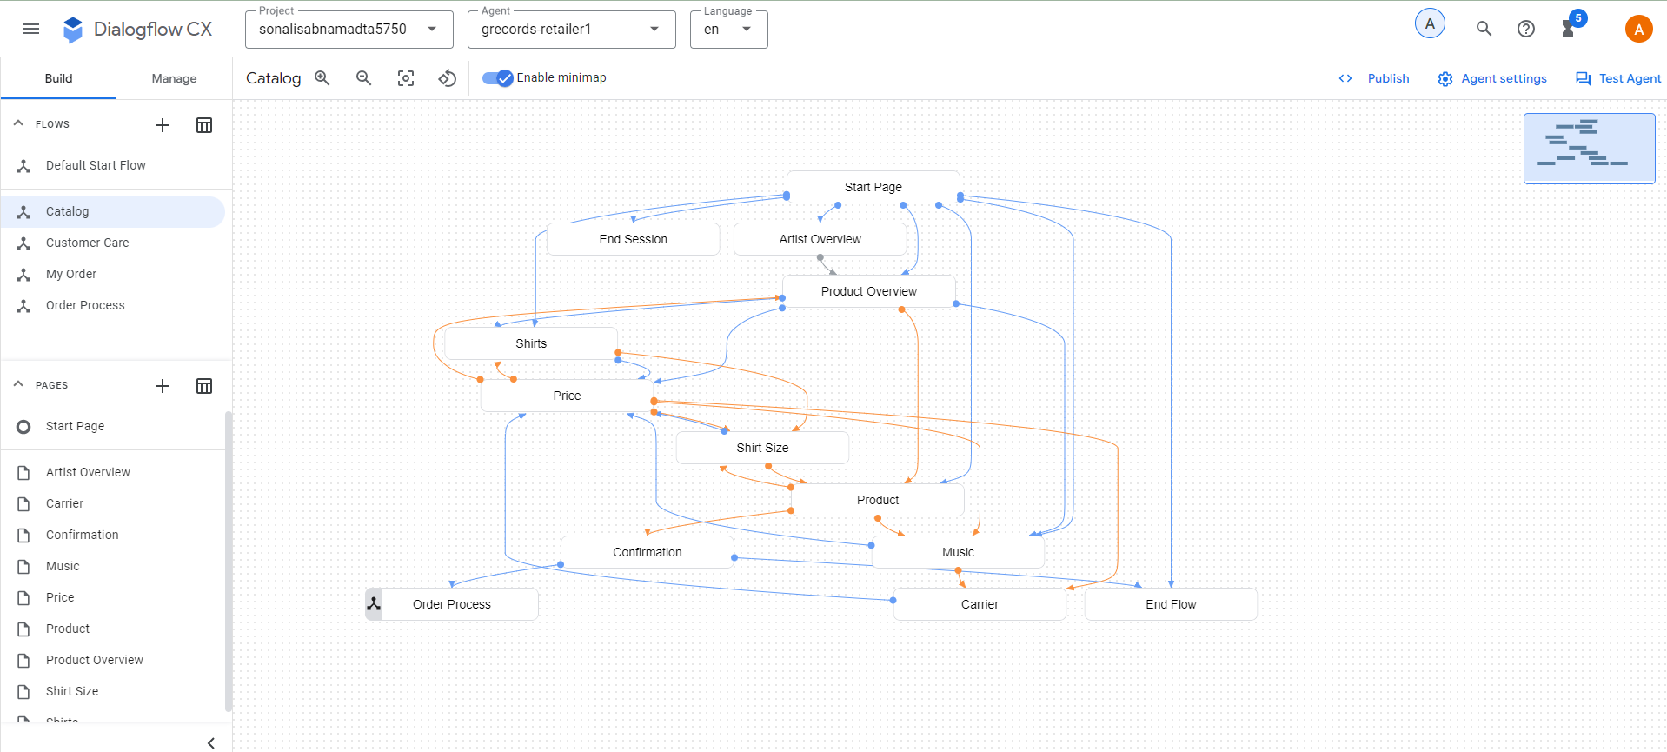
- Price Page
- Click on the Catalog Flow, Price page
- Delete the existing entry fulfilment if any.
- Create the below conditional response
if $session.params.category = "shirts"
A t-shirt costs $25 and a longsleeve costs $30.
elif $session.params.category = "music"
A CD costs $15. The digital album on MP3 costs $10.
else
A t-shirt costs $25 and a longsleeve costs $30. A CD costs $15 and a digital album on MP3 $10. In case you are interested in the Tour Movie, that one is $25.
endif
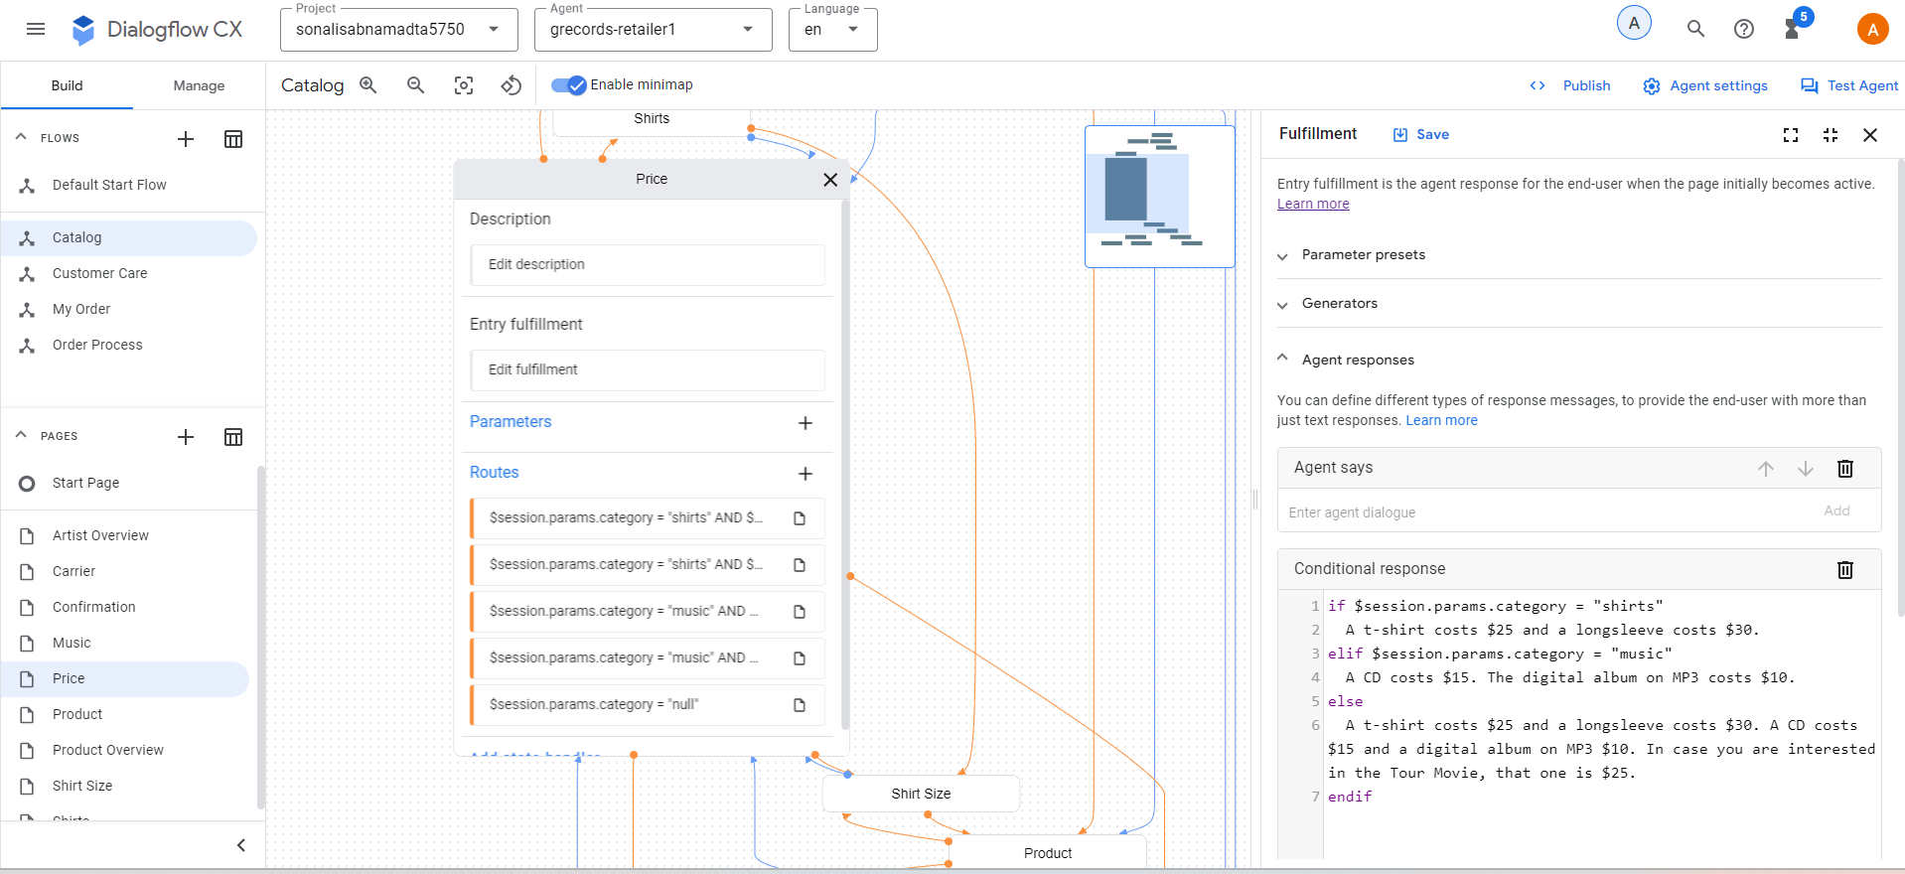
- Till now the agent looks like this
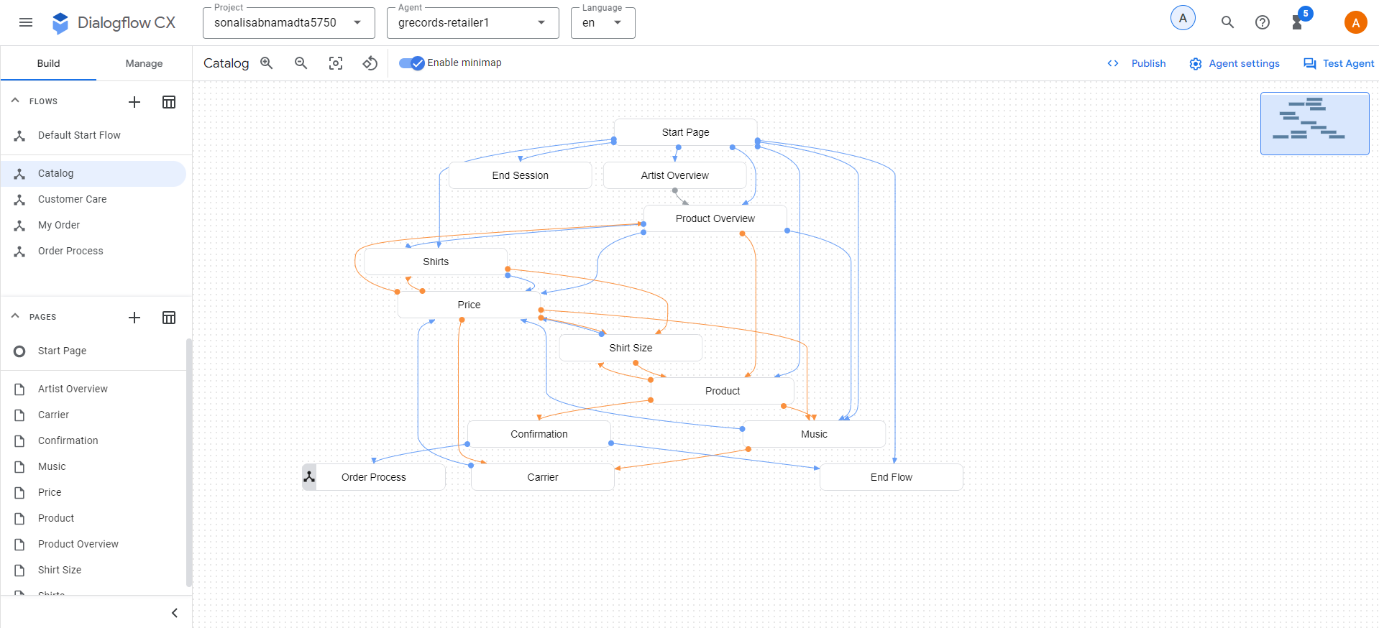

TO-DO #4: Next, complete the steps to wrap up the virtual retail agent.

Objective: As we are done with creating the necessary components for the virtual agent, in this section we have tried to complete the few flows to wrap up the agent.

Creating “My Order” flow
- Select “My Order” flow and create the below intent transitions
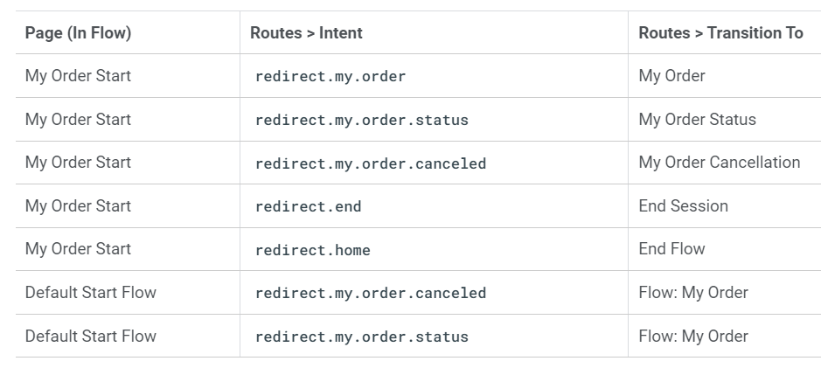
- Once the intent transitions are created, the my order flow looks like the below screenshot.
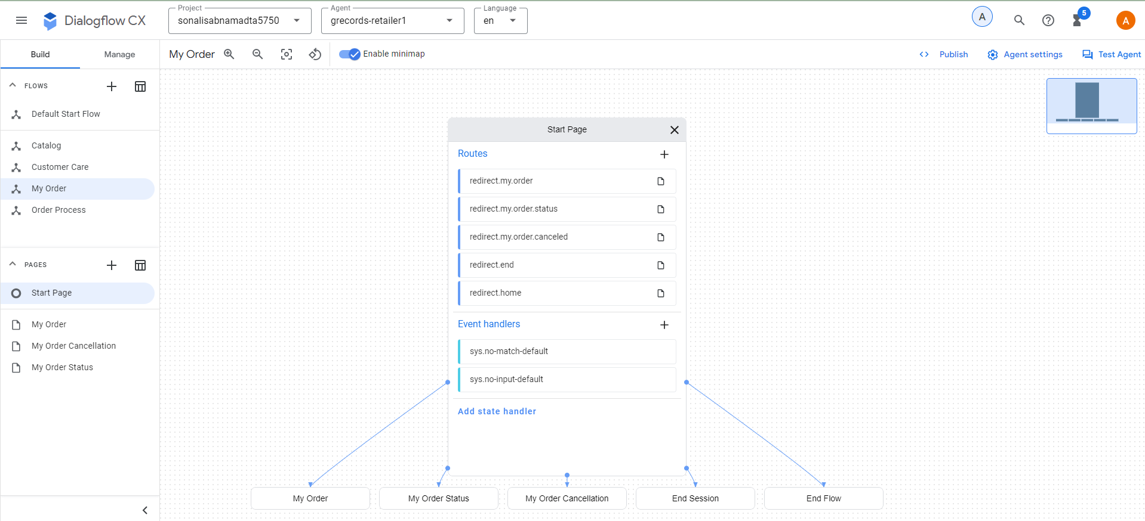
- The default start flow looks like the below screenshot.
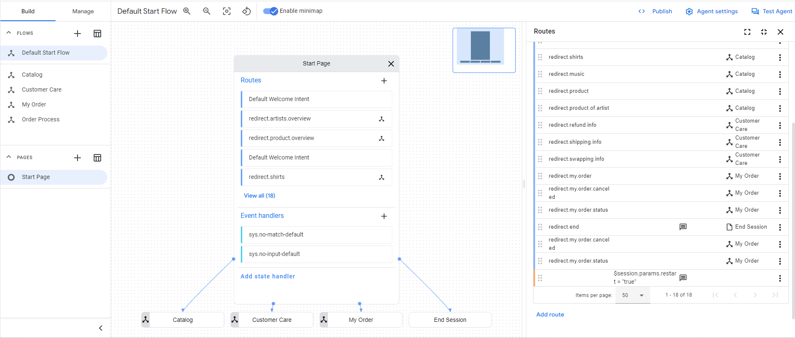
- Create fulfilment for the “My Order” page
- Fulfilment: I can look up the status of your order, or I can cancel an order.
- In My Order page, create the below parameter.
- Displayname: ordernumber, Entity Type: @OrderNumber, Required: checked,Initial prompt fulfillment: What's the order number? For example ABCD123.
- Event Handler: No-match default: To proceed with your order I will need an order number. Order numbers start with 4 characters and end with 3 numbers, such as ABCD123. Which order number may I use?
- Event Handler: No-input default: I missed that. To proceed with your order I will need an order number. Order numbers start with 4 characters and end with 3 numbers, such as ABCD123. Which order number may I use?
- Create the below conditional route:
- Customize Expression: $page.params.status = "FINAL",Fulfillment: And do you want to Cancel your order, or should I look up the status?
- Add a state handler with the below steps
- Add state handler > Event Handlers and click on the “Event Handler” and select “No-input default”.
- Fulfillment: I'm sorry, what was that? Would you like me to cancel an order or look up the status?
- Custom payload:
- {
"richContent": [
[
{
"options": [
{
"text": "Status"
},
{
"text": "Cancel"
}
],
"type": "chips"
}
]
]
}
- Create event handler “No-match default”
- Fulfillment: Would you like me to cancel an order or lookup the status?
- Custom payload:
- {
"richContent": [
[
{
"options": [
{
"text": "Status"
},
{
"text": "Cancel"
}
],
"type": "chips"
}
]
]
}
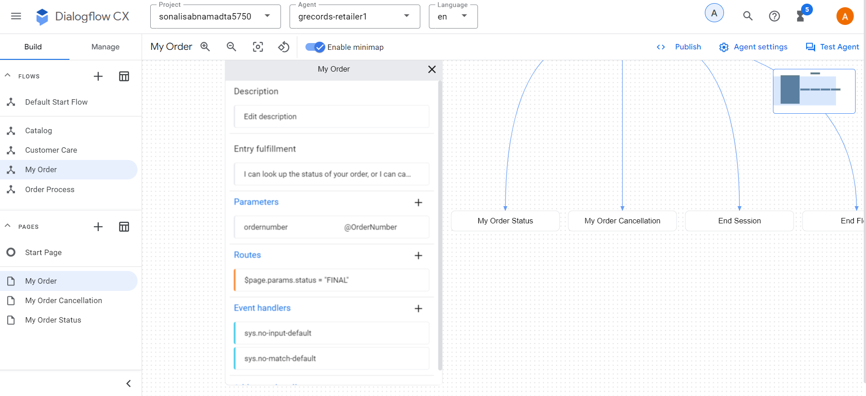
My Order Status Page

- In the “My Order Status” Page, create the following parameter:
- Displayname: ordernumber, Entity Type: @OrderNumber, Required checked
- Initial prompt fulfillment: What's the order number? For example ABCD123.
- Event Handler: No-match default: To proceed with your order I will need an order number. Order numbers start with 4 characters and end with 3 numbers, such as ABCD123. Which order number may I use?
- Event Handler: No-input default: I missed that. To proceed with your order I will need an order number. Order numbers start with 4 characters and end with 3 numbers, such as ABCD123. Which order number may I use?
- In My Order Status Page create the following conditional route:
- Customize Expression: $session.params.ordernumber != null, Fulfillment: Your order $session.params.ordernumber has been shipped, it can take up to approx 2 weeks before you will receive your items.
- Add dialogue option > Text: Is there anything else I can help you with?
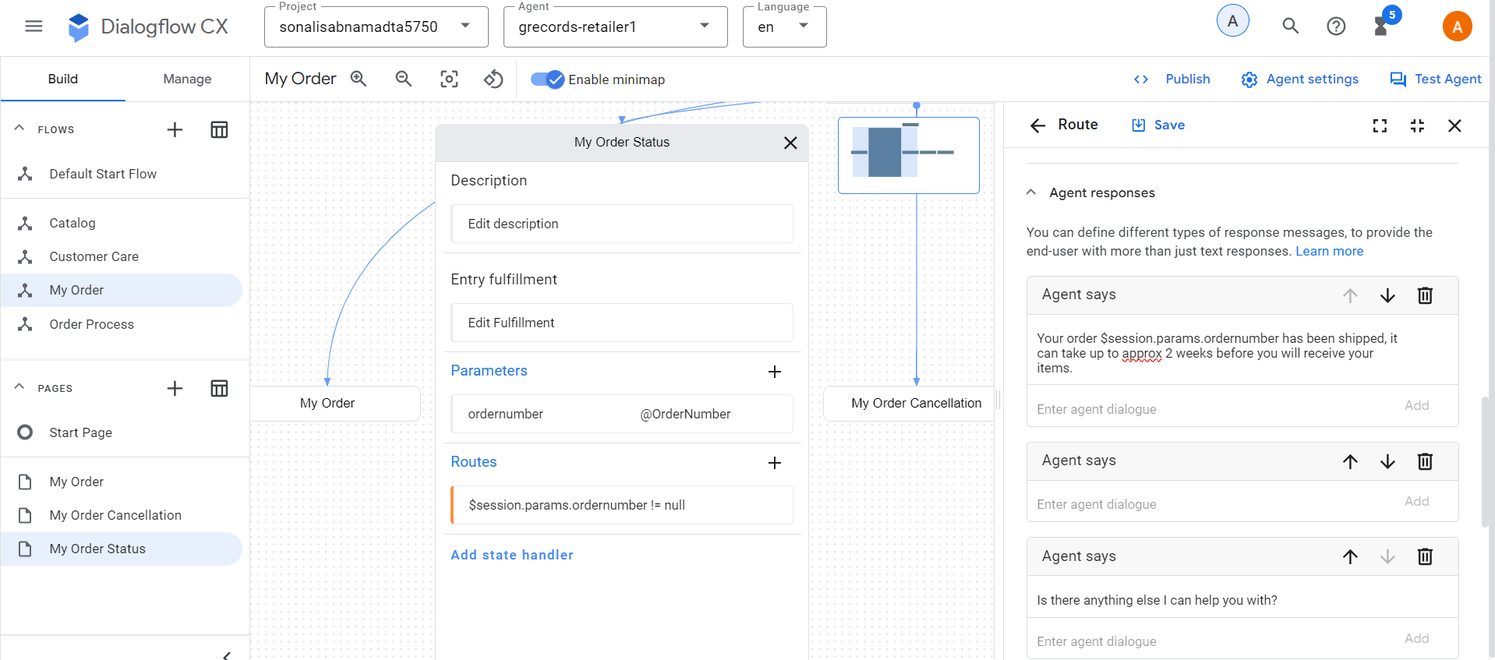

Order Cancelation Page
- In the My Order Cancelation Page create the below parameter:
- Displayname: ordernumber, Entity Type: @OrderNumber, Required checked
- Initial prompt fulfillment: What's the order number? For example ABCD123.
- Event Handler: No-match default: To proceed with your order I will need an order number. Order numbers start with 4 characters and end with 3 numbers, such as ABCD123. Which order number may I use?
- Event Handler: No-input default: I missed that. To proceed with your order I will need an order number. Order numbers start with 4 characters and end with 3 numbers, such as ABCD123. Which order number may I use?
- My Order Cancelation Page create the following conditional route:
- Customize Expression: $session.params.ordernumber != null, Fulfillment: Your order $session.params.ordernumber has been canceled.
- Add dialogue option > Text: Is there anything else I can help you with?
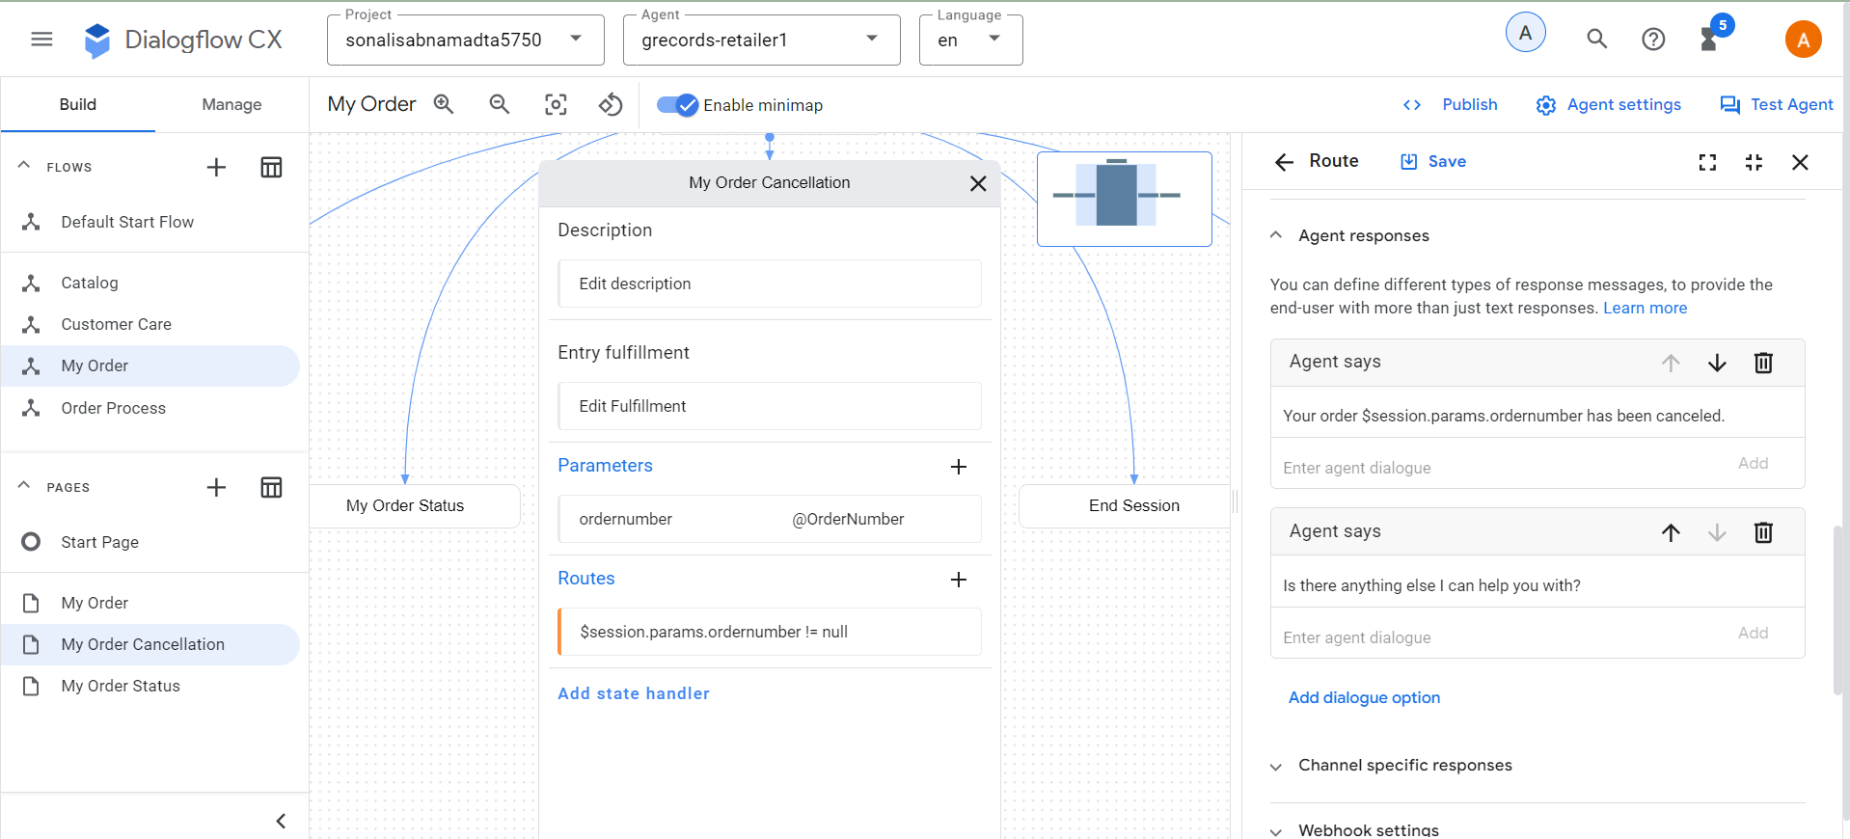
- In the Start Page and click on the redirect.end intent. Create the following fulfillment: Thank you for contacting G-Records! Have a nice day!
- Select the Start Page and click on the redirect.home intent. Create the following parameter preset: restart = true

- Default Negative intents

- Click Manage > Intents and select the Default Negative Intent.
- Add the below training phrases that will trigger the No-match event.
  - I don't like Alice Googler
  - I am not a fan of G's N' Roses
  - I can't stand the music of the Google Dolls
- Hit Save and write the below sentence in the simulator.
  - I am really not a fan of the Goo Fighters
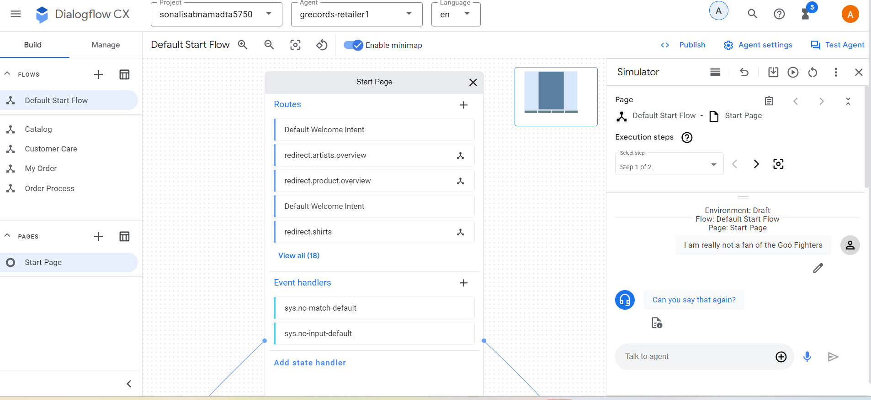
- This triggered the “no match” event and the control was in start page.
- Default Start Flow, select the sys.no-input-default event handler.
- Remove all answers, and add these text dialogues:
  - I'm sorry, I didn't receive an answer. Can you say it again?
  - I missed your answer, can you say it again?
  - Sorry, I didn't hear anything. Can you say it again?
  - I couldn't hear what you were saying, what was that?
  - I'm sorry, I missed your answer. What were you trying to say?
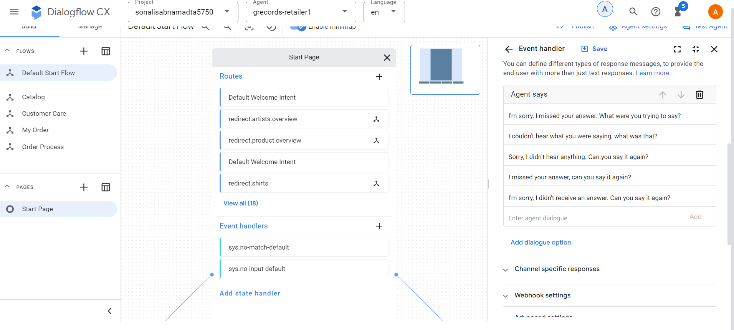
- Default Start Flow, select the sys.no-match-default event handler
- Remove all answers, and add these text dialogues:
  - Sorry, I didn't get that. Can you please rephrase?
  - I'm sorry, I don't understand. Can you please rephrase?
  - I don't understand, please rephrase.
  - Sorry, I didn't get that. What was that?
  - I didn't get that, can you please rephrase?
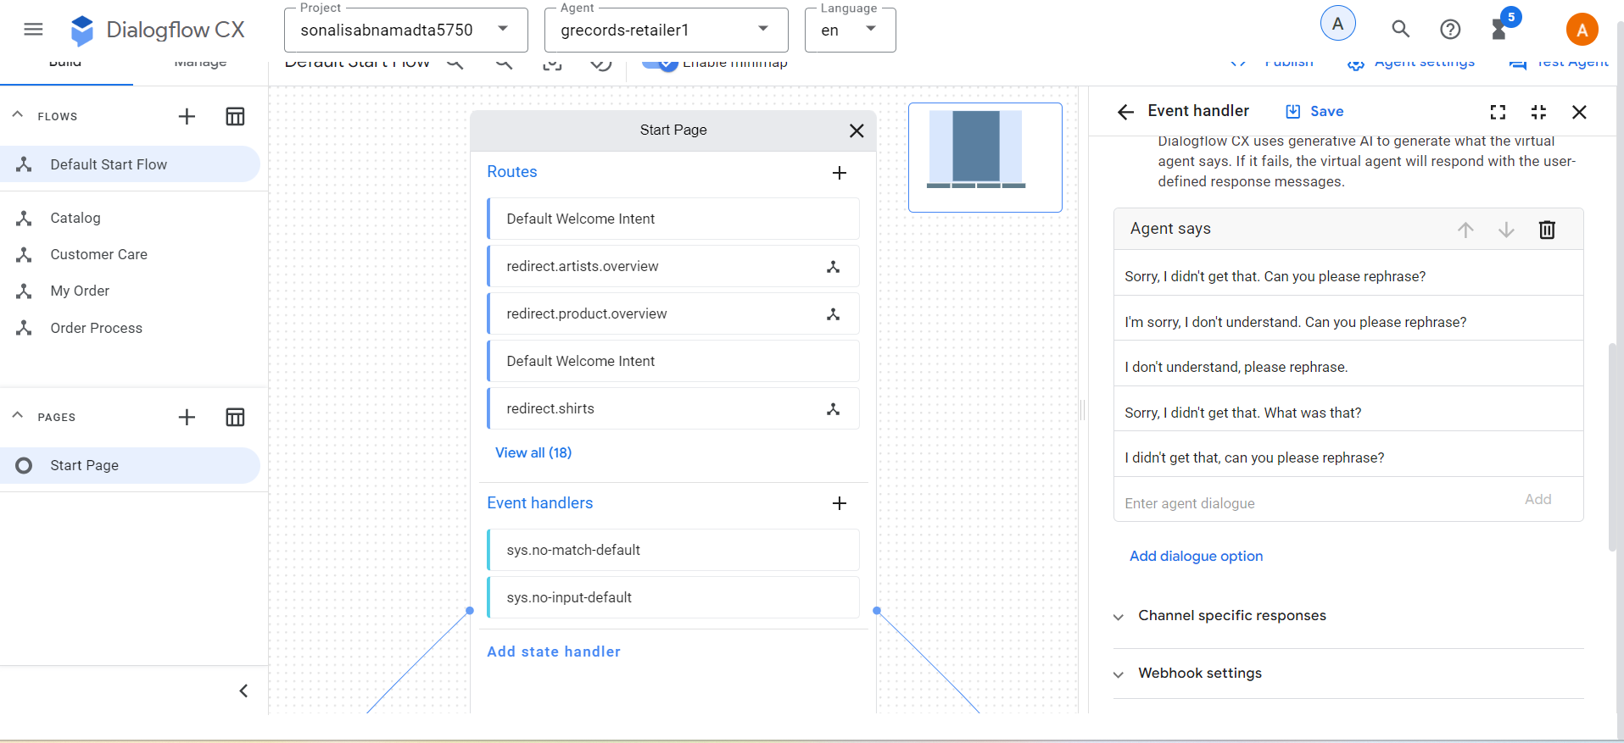
- Repeat these steps for the Catalog, My Order, Order Process and Customer Care flows.
- Catalog flow:
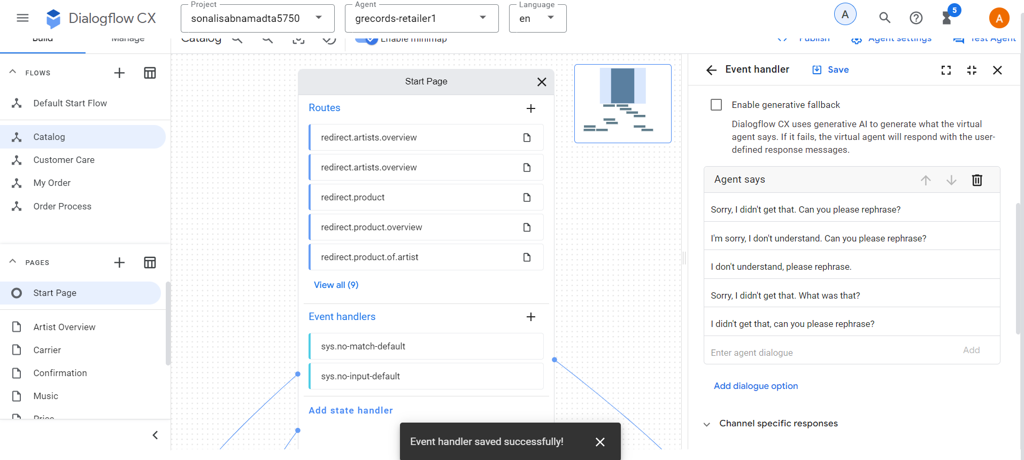
- My Order Flow:
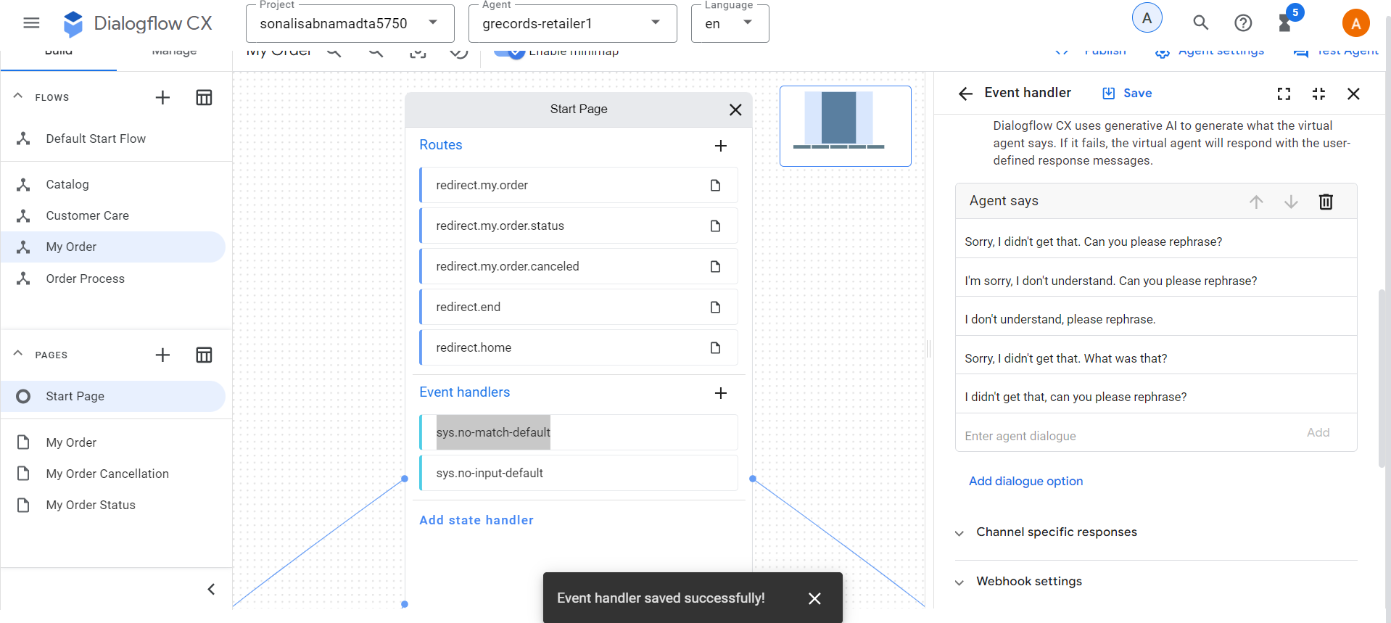
- Order Process Flow:

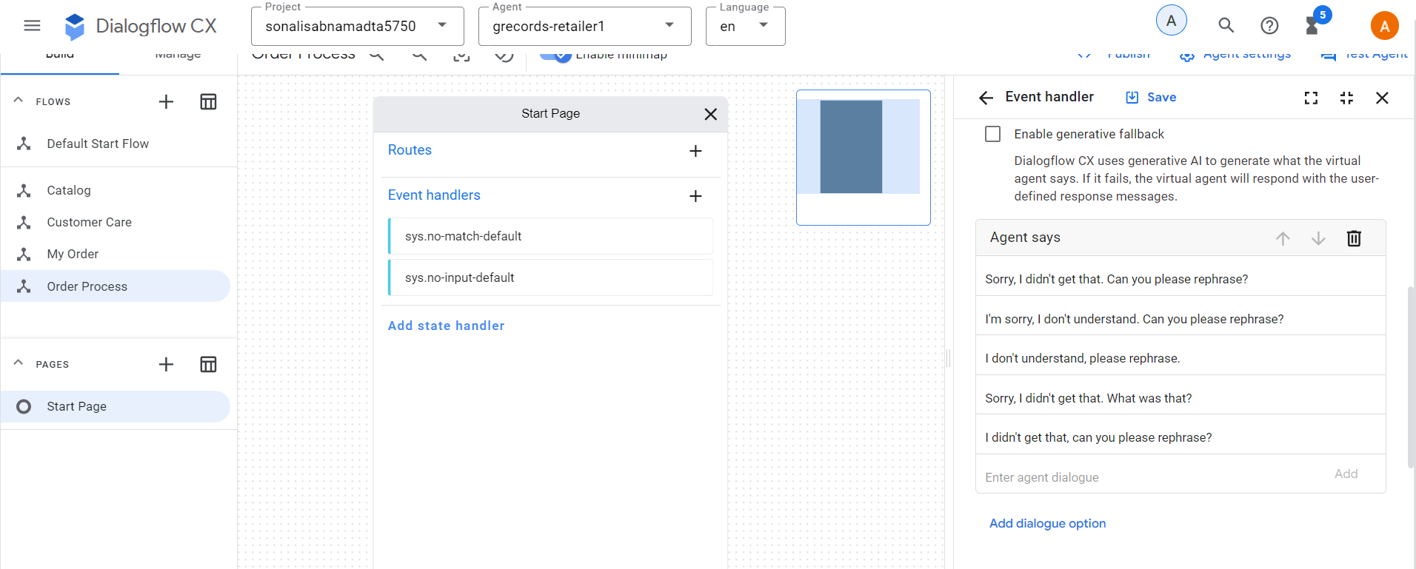
- Customer Care Flow:
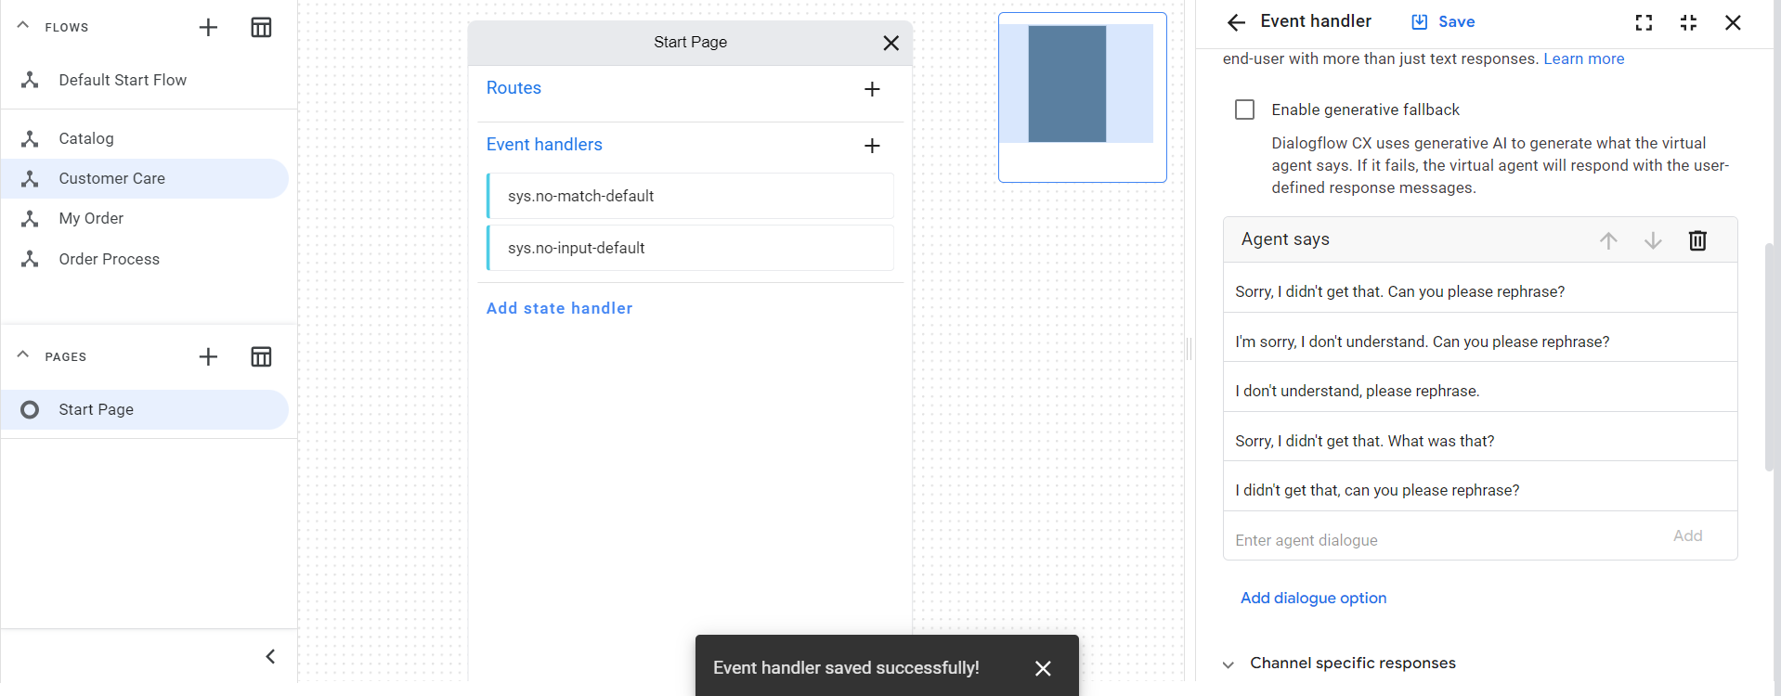

- Creating the Order Process Flow
- Go to the Order Process flow and create the below intent transitions.
- Order Process Start > redirect.end > Transition: End Session
- Order Process Start > redirect.home > Transition: End Flow
- Order Process Start > confirm.proceed.order > Transition: New Page: Shipping Details
- Enter the fulfilment for Shipping Details page “To complete your order I will first need to collect your shipping details.”
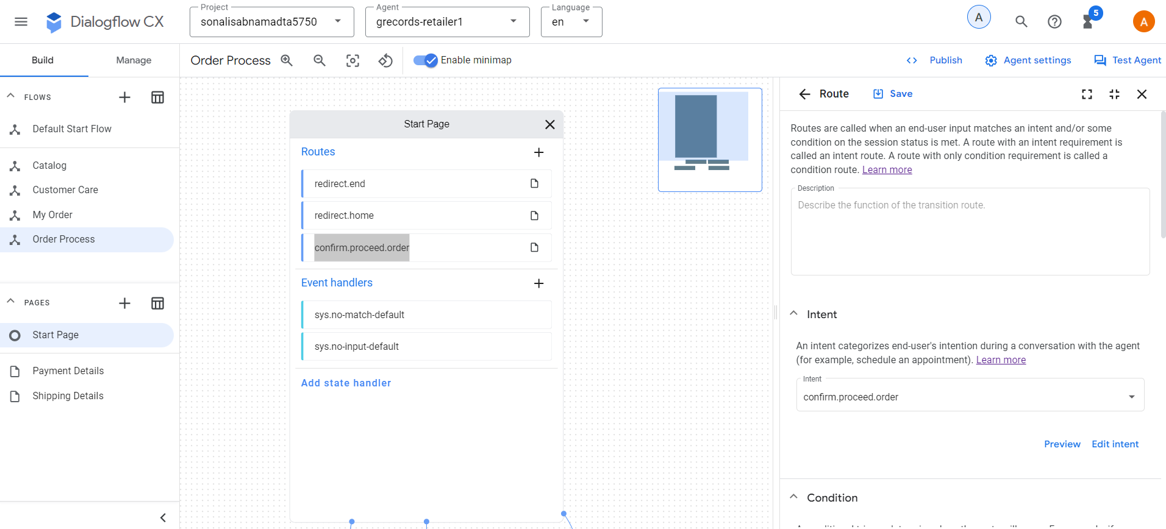
- Create the below parameters
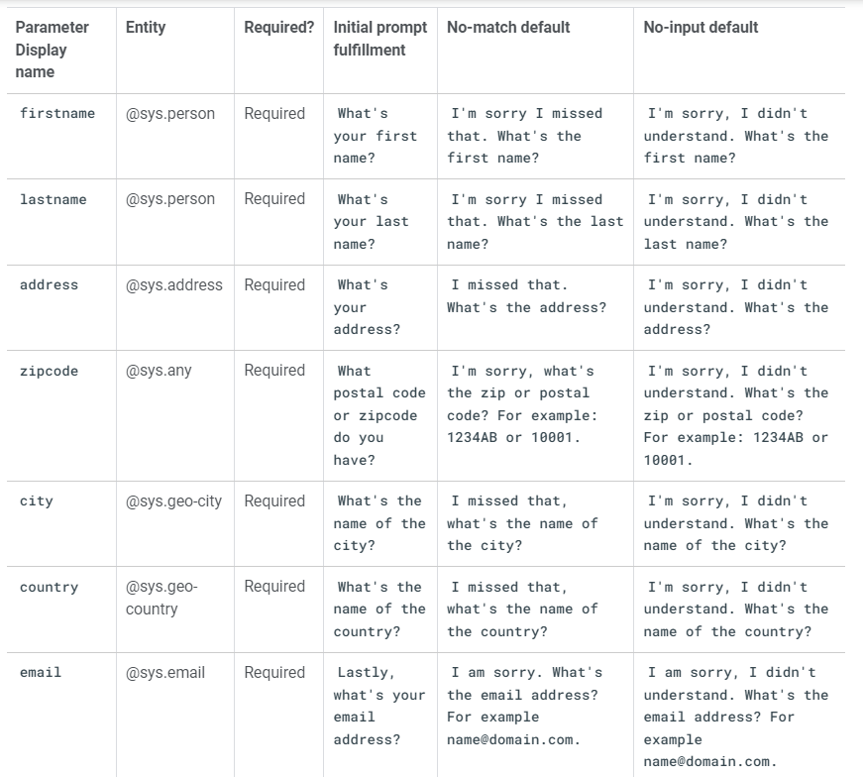
- The below screenshot displays the parameters successfully created for the Shipping Details page.
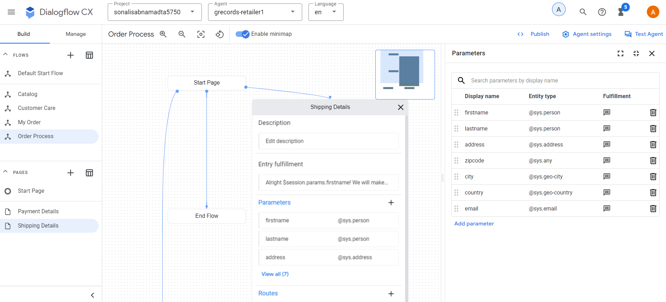
- Create the following conditional route:
- Customize Expression: $page.params.status = "FINAL", Transition to new Page: Payment Details
- Fulfilment: Alright $session.params.firstname! We will make use of Google Pay, that's connected to your email account: $session.params.email.
- Conditional Response:
- if $session.params.merch != "Digital Album"
Shipping costs an additional 5 dollars. This will make the total price $$sys.func.TO_TEXT($sys.func.ADD($session.params.price, 5)).
Your merchandise will be shipped to:
$session.params.firstname $session.params.lastname
$session.params.address
$session.params.zipcode $session.params.city
$session.params.country
To continue the order process please explicitly say "I confirm". Do you want to confirm your $session.params.artist $session.params.merch order?
else
The total costs will be: $$session.params.price.
After purchasing the digital album, you will receive an email with the download link.
To continue the order process please explicitly say "I confirm".
Do you want to confirm your $session.params.artist $session.params.merch order?
endif

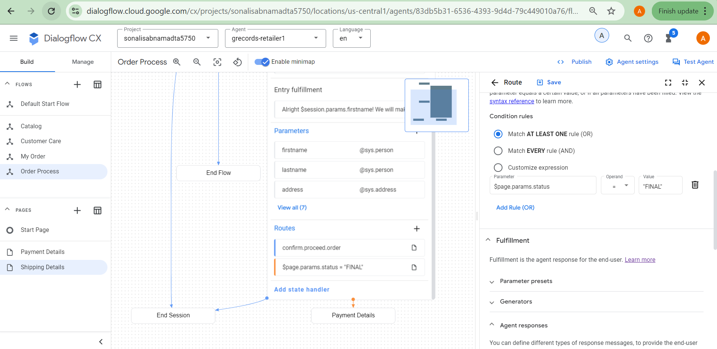

- Create the below intent route:
- Intent: confirm.proceed.order
- Agent Says: Thank you for your order! Your merchandise will be shipped today!
- Add Dialogue Option > Text: Here's the order number: ABCD123.
- Add Dialogue Option > Text: Have a good day!
- Transition: End Session
- Start page > redirect.end > fulfillment: Thank you for contacting G-Records! Have a nice day!
- Start page > redirect.home > parameter preset: restart = true

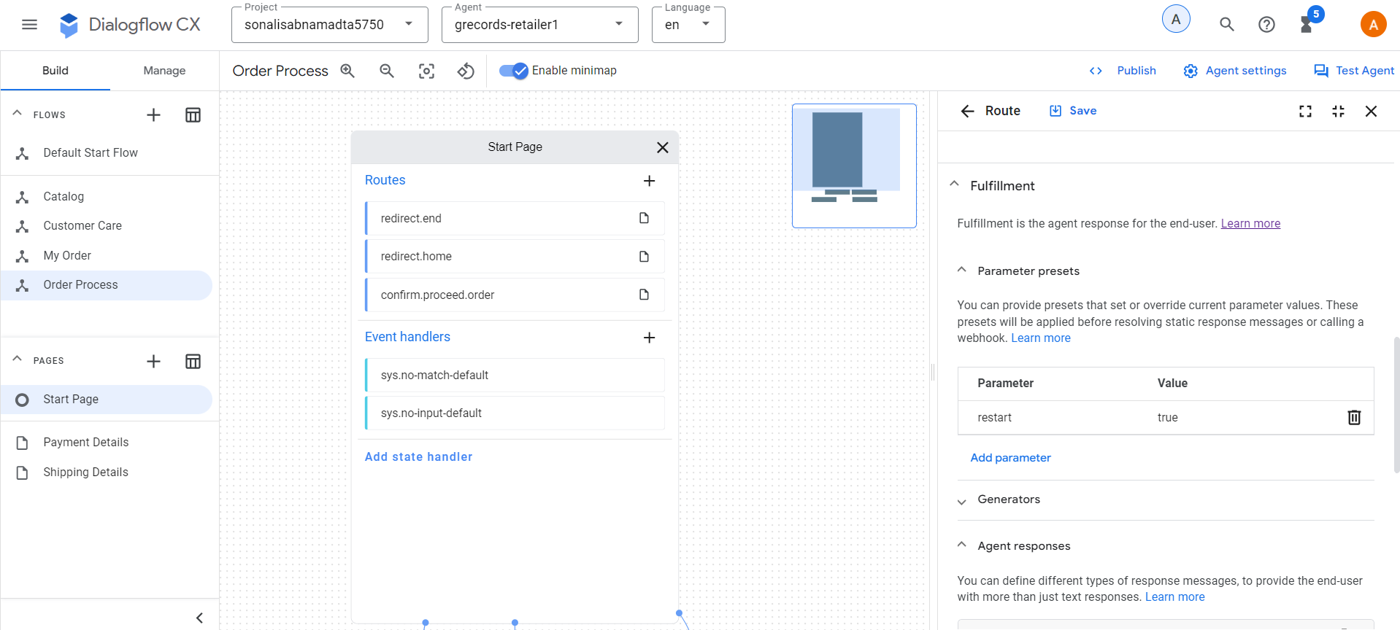

Till now the flows look like the below screenshots:
Default Start Flow:
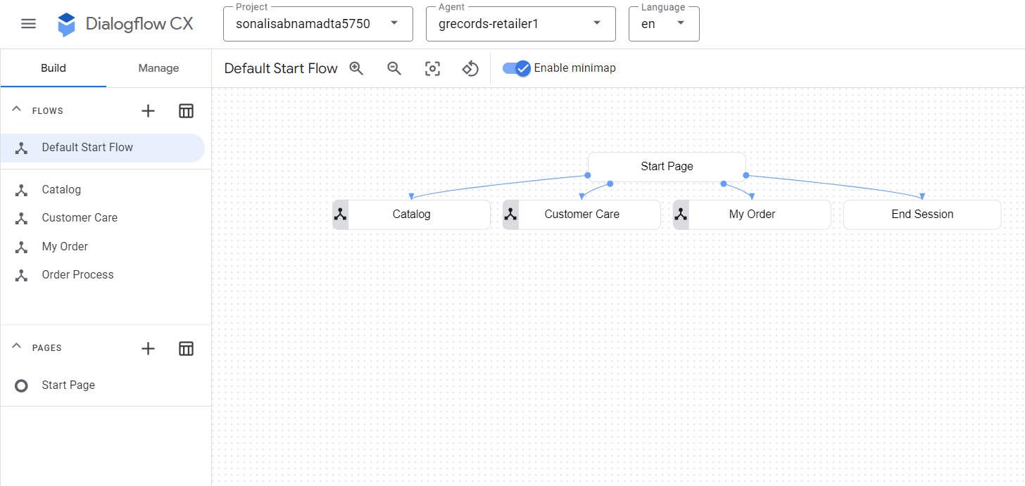
Catalog Flow:
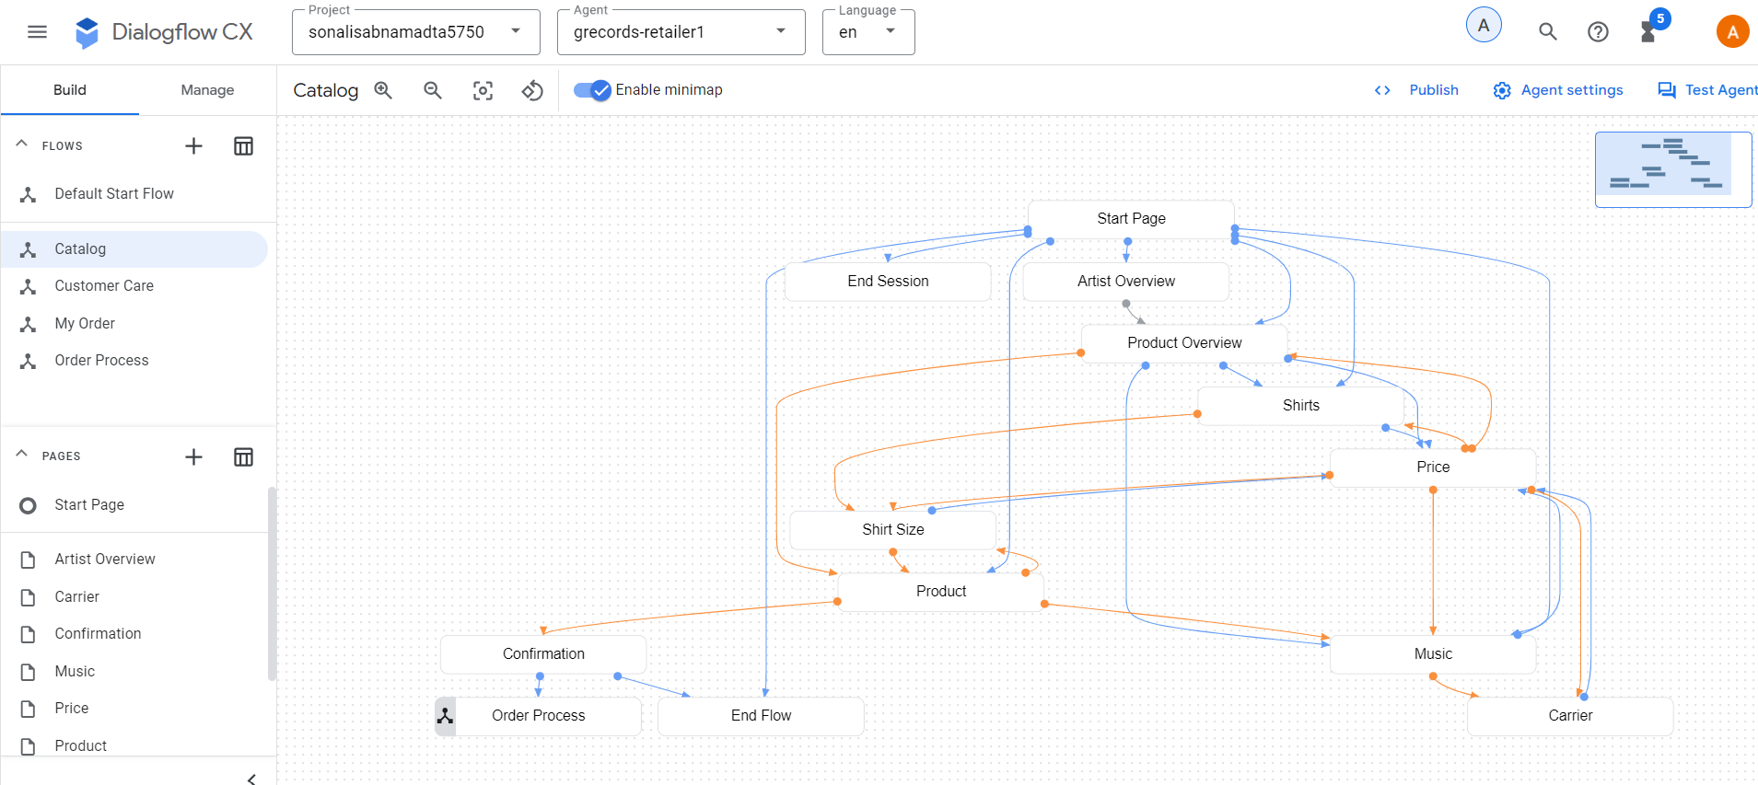
My Order Flow:
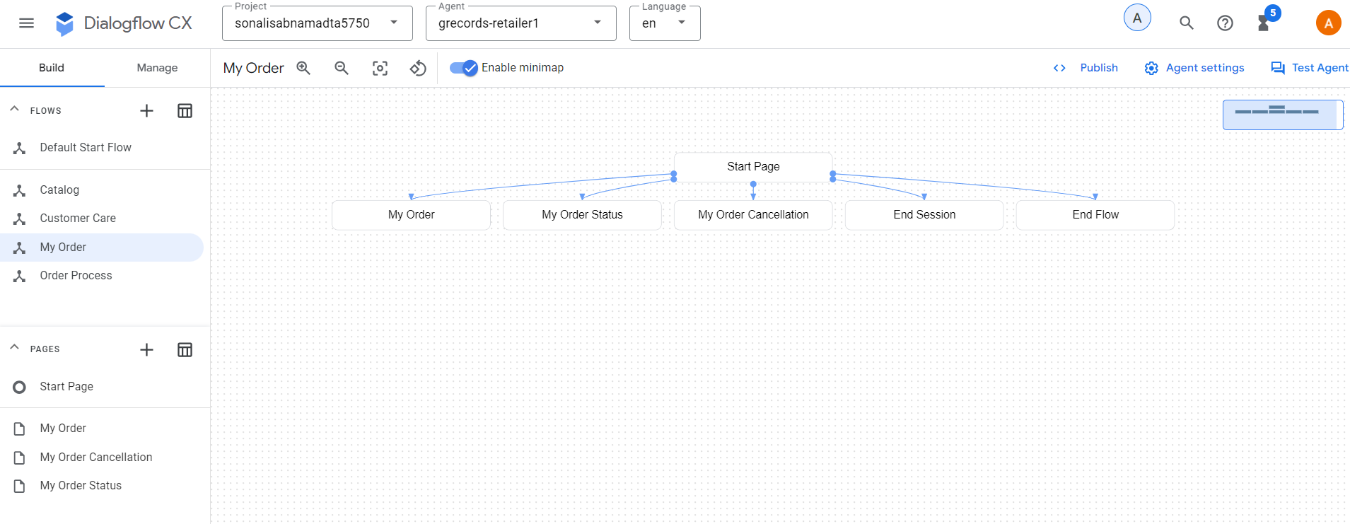
Order Process:
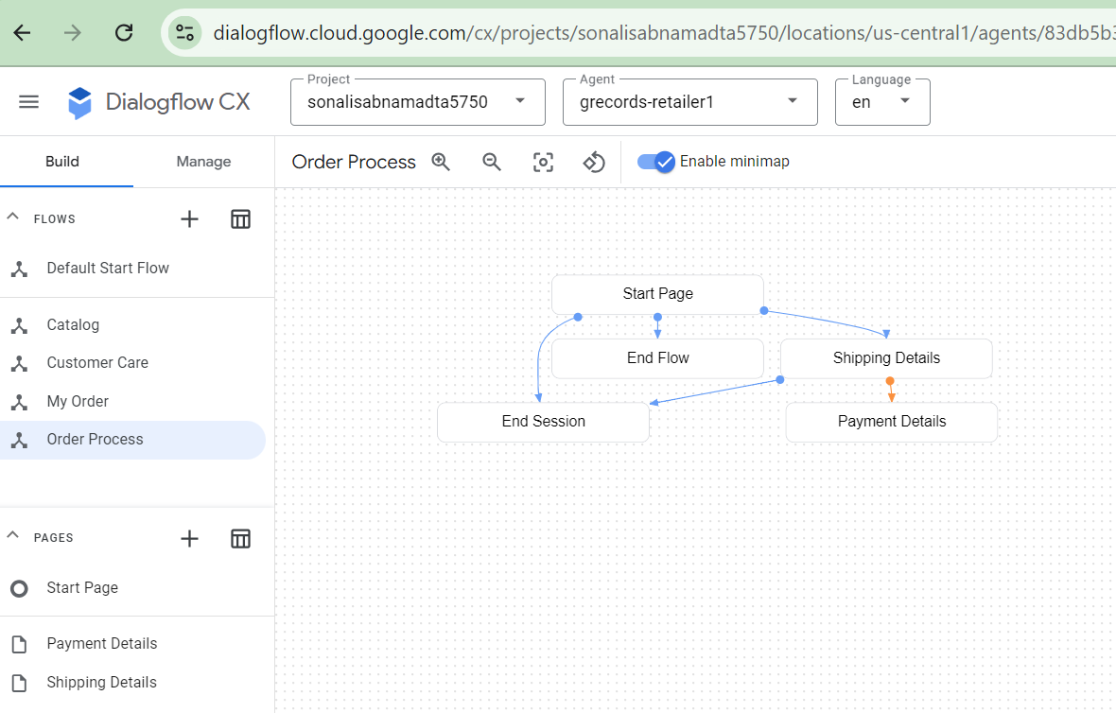

TO-DO #5: Finally, complete the steps to test the virtual retail agent.

Objective: To use the built-in simulator to test the dialogues of the virtual agent. This provides an overview of Flows, Pages and Parameters and Events collected by the simulator while navigating through the flow. With this we can test it before it is integrated to be used by the customers. We can also create test cases, save them and reuse.

- Create the Customer Care Flow
- Select the Customer Care flow and create the below intent transitions:
- Customer Care Start > intent: redirect.shipping.info > Transition: Shipping
- Customer Care Start > intent: redirect.refund.info > Transition: Refund
- Customer Care Start > intent: redirect.swapping.info > Transition: Swapping
- Customer Care Start > intent: redirect.home > Transition: End Flow

- Customer Care Start > intent: redirect.end > Transition: End Session

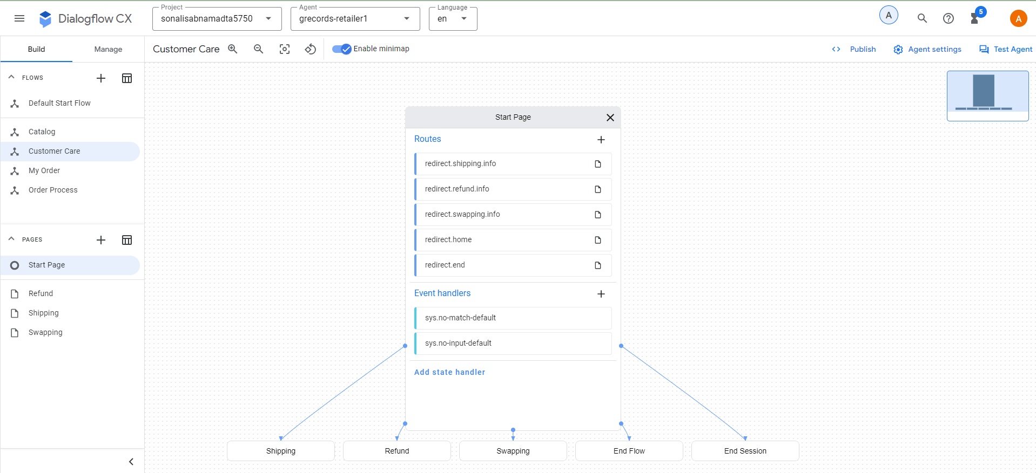
- Add the below Entry fulfillments for the Shipping Page:
  - Shipping physical merchandise items can take up to 2 weeks.
  - Is there anything else I can help you with?
- Add the below Entry fulfillments for the Refund Page:
  - We offer free returns and refunds. We provide one free return label for each order. You can use it within 30 days from receiving your order. If your refund is accepted, we will refund the price you paid for your item back to your original payment method.
  - Is there anything else I can help you with?
- Add the below Entry fulfillments for the SwappingPage:
  - If you would like to change your item for a different one, please return your unwanted item and place a new order. If your refund is accepted, we will refund the price you paid for your item back to your original payment method.
  - Is there anything else I can help you with?
- Select Start page > intent: redirect.end > fulfillment: Thank you for contacting G-Records! Have a nice day!
- Select Start page > intent: redirect.home > parameter preset: restart = true

Create test cases
- Click on the “Create Test Cases” button on the right side of the screen
- Select the “draft” environment and type the following:
  - Hi
  - Which artists are signed with your label?
  - The Google Dolls
  - I am interested in buying a shirt
  - A t-shirt
  - Medium
- Click on the save test cases button and provide the following details:
- Test case name: Buy Google Dolls t-shirt size M
- Tags: #catalog, #shirts, #t-shirt, #TheGoogleDolls
- Click on Save.
- The test case gets created.
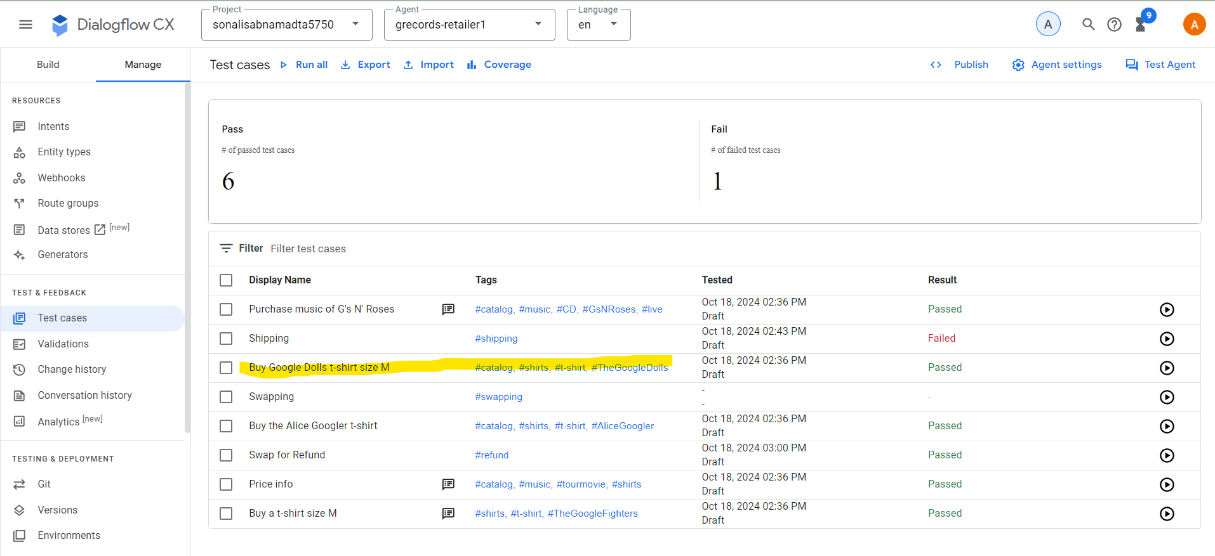
- Refresh the dialog and create the below test case:
- "Buy the Alice Googler t-shirt."
- "XL"
- Test case name: Buy the Alice Googler t-shirt
- Tags: #catalog, #shirts, #t-shirt, #AliceGoogler
- Save
- "Buy a t-shirt size M"
- "The Google Fighters"
- Test case name: Buy a t-shirt size M
- Tags: #catalog, #shirts, #t-shirt, #TheGoogleFighters
- Description: (Note the Artist name hasn't been mentioned, but you do want to skip the bands overview, products overview, shirts and shirt size pages)
- Save
- "Purchase music of G's N' Roses"
- "Live"
- "CD"
- Test case name: Purchase music of G's N' Roses
- Tags: #catalog, #music, #CD, #GsNRoses, #live
- Description: (Note this will skip the bands overview and products overview page)
- Save
- "Which products"
- "Shirts"
- "What's the price difference?"
- "Longsleeve"
- "What does it cost?"
- "M"
- "The Google Dolls"
- "No"
- "Which bands"
- "The Gooo Fighters"
- "Music"
- "How much does it cost?"
- "Greatest Hits"
- "What's the price difference?"
- "Mp3"
- "No"
- "I want to buy the tour movie"
- "Alice Googler"
- "Yes"
- Test case name: Price info
- Tags: #catalog, #music, #tourmovie, #shirts
- Description: Test price info on various points in the dialogue
- The below screenshot shows the Test cases created successfully.
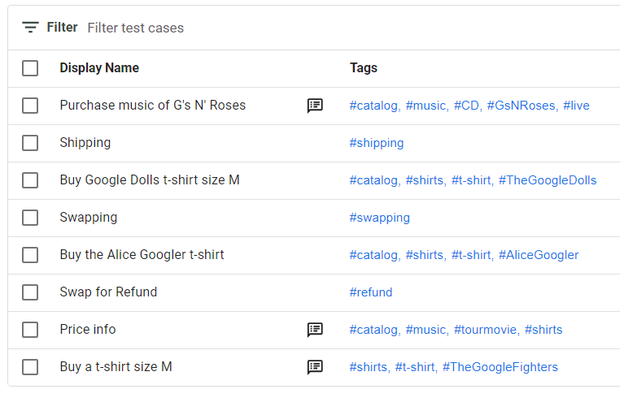

Test pre-recorded test cases
- Select Manage > Test Cases
- Select all the test cases and click on Run.
- The below screenshot displays the Test case execution results.
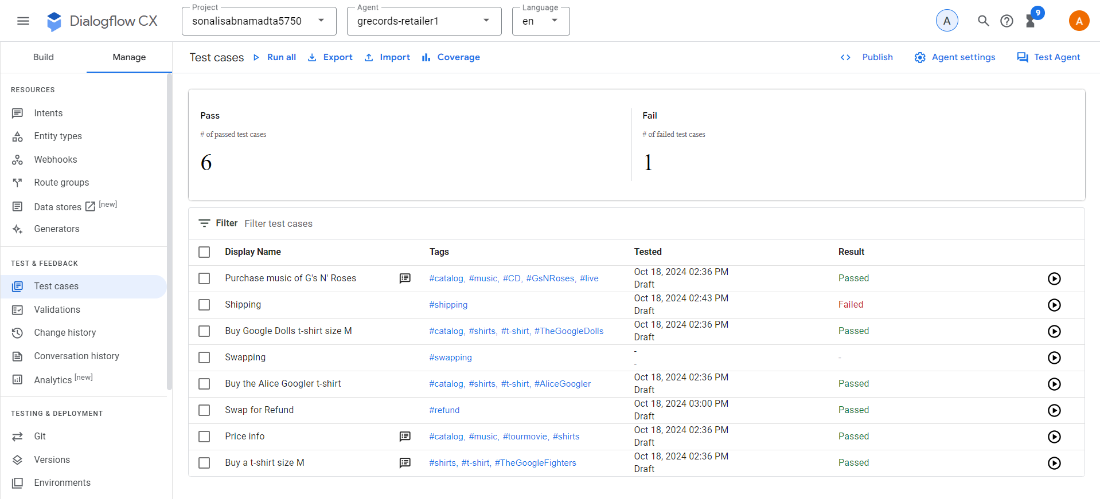
- Create the below test case.
- “How long will shipping take?”
- Test Case Name: Shipping
- Tag: #shipping
- Run the Test case from Manage > test cases
- This Test case should pass.

- Select the Customer Care flow > start page > Routes
- Remove the “redirect.shipping.info route”
- Run the “shipping” test case from Manage> Test Cases
- This test case fails as the page does not exists in the flow anymore.
- This is a missed request , a False Negetive test result. The test failed, we were expecting the “Shipping Page” but nothing happened.
- The below screenshot displays the same.

- Select Customer Care flow and add intent route “redirect.shipping.info” to the start page. Transition to the shipping page and save.
- Record the following test case in the simulator
- “I want to swap my item”
- Test Case Name: Swapping
- Tags: #swapping
- Go to Manage >Intents > redirect.refund.info and add training phrase: I want to swap this item for a refund.
- Create the below test case
- “I want to swap this item for a refund”
- Test Case Name: Swap for Refund
- Tag: #refund
- Remove the intent from Manage >Intents > redirect.refund.info and remove the intent line I want to swap this item for a refund
- Now, run the “Swap for Refund” test case.
- This failed with the below error message
- “If you would like to change your item for a different one, please return your unwanted item and place a new order. If your refund is accepted, we will refund the price you paid for your item back to your original payment method.`
Is there anything else I can help you with?
Page: Page mismatch:
Expected: Refund
Actual: Swapping”
- This is a false positive test result. The test failed, expected: Refund Page, but Swapping page became active.

Coverage:
- The more is the coverage for a test case the lower is the chance of containing the undetected bugs like miss understood requests compared to the test case with less coverage.
- Go to Manage> Test cases > Coverage > Transitions to see the coverage report for transitions.
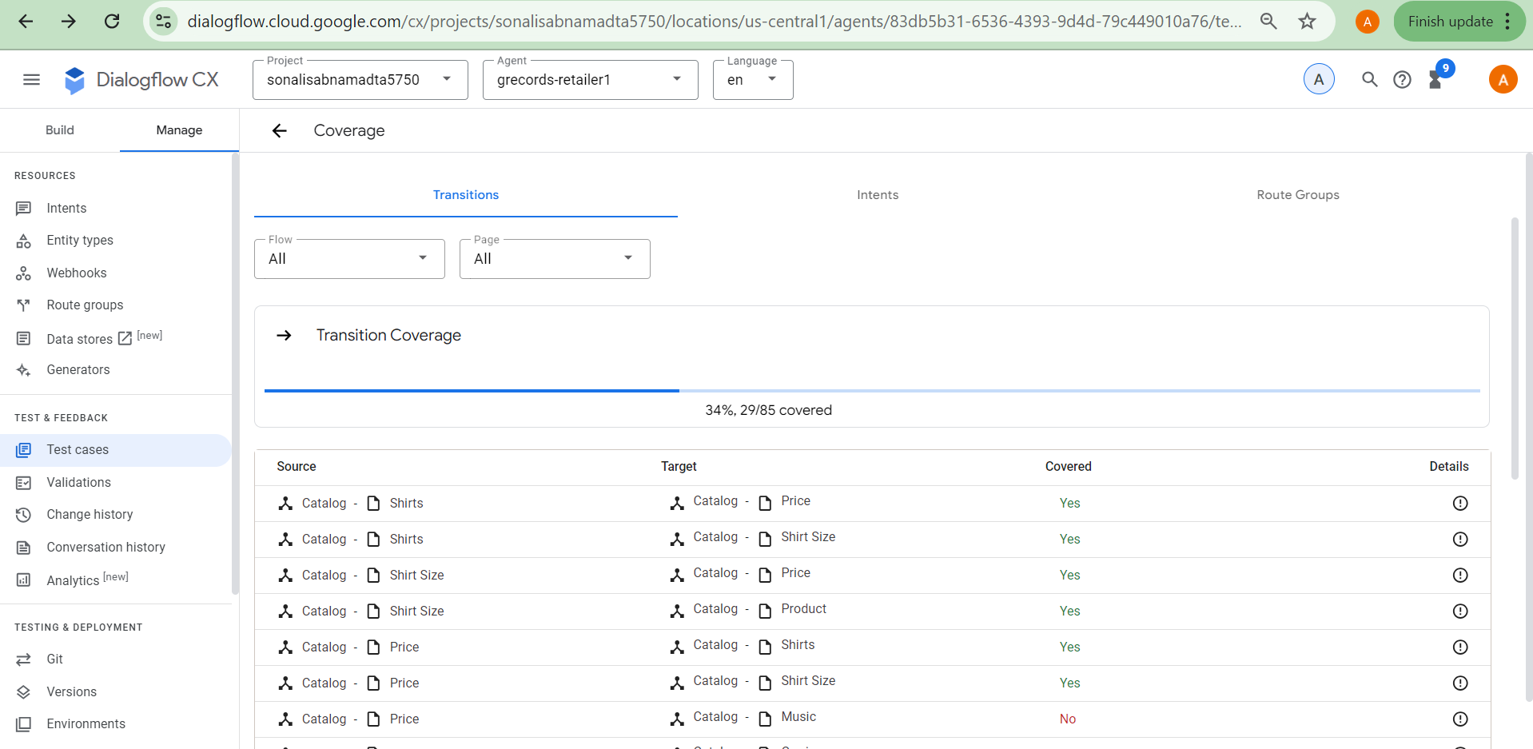
- Click on the intents tab to get the coverage for the intents.
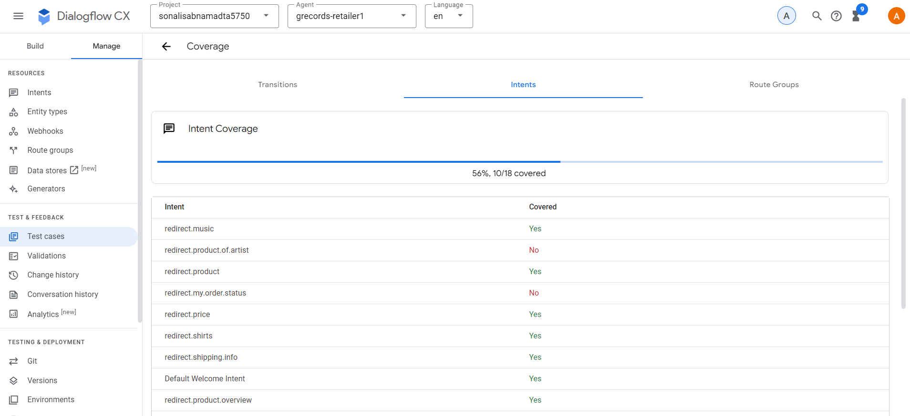

- With this we have successfully built and tested a real time retailer chat-bot and tested it.

Conclusion:
As part of this assignment, we have used the conversational AI platform of DialogFow CX to build a powerful and complex virtual agent (chat bot) which can handle multi-turn conversations efficiently. Unlike DialogFlow ES, the intents here can be reused.
The figure below displays the virtual agent, and we can see the various conversational paths leading to various directions.

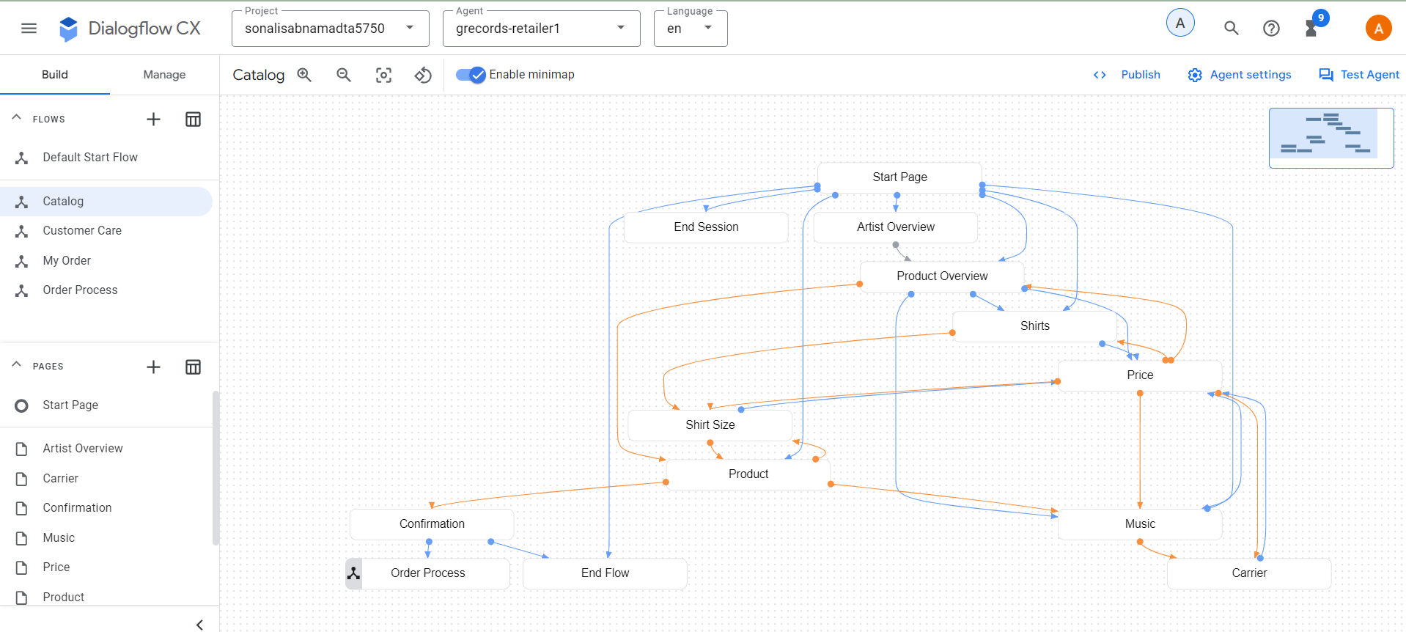

References:
https://codelabs.developers.google.com/codelabs/dialogflow-cx-retail-agent#0
https://cloud.google.com/dialogflow/cx/docs/concept/entity-options

